Bluevale Collegiate Institute
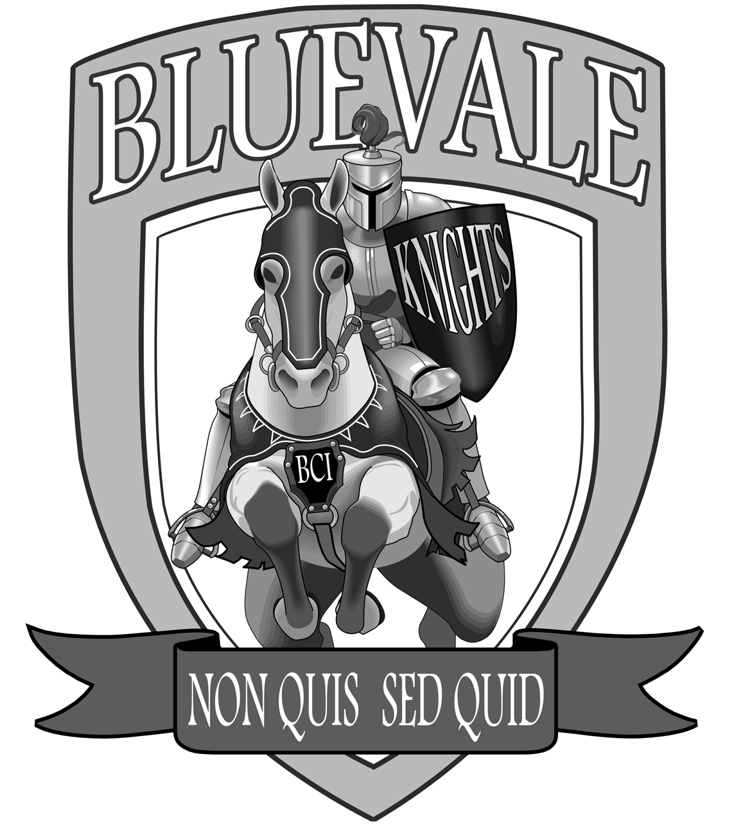

GRADE 10-12 Course Offerings

2018-2019

- Individual course descriptions, prerequisites and subject flow charts are detailed in The Common Course Calendar available online at:
http://www.wrdsb.ca (Secondary School Information – Course Selection Process)
- This booklet provides a listing of all Grade 10-12 courses offered at Bluevale. Courses are subject to run based on enrolment and staffing.
- Research and choose your courses carefully. Course changes at the start of each semester are not easily accommodated. You are recommended to consult your guidance counsellor, parents and teachers when making course selections and long-term decisions..
- C = College, O = Open, U/C or M = University/ College, U = University, E = Workplace

NUMBER OF COURSES REQUIRED PER GRADE:
Students require 30 courses (18 compulsory and 12 elective) in order to graduate. Grade 10 students require a minimum of EIGHT courses. Students in Grades 11 and 12 must take a minimum of SIX courses. Students under the age of 18 are required to maintain full time status throughout the school year.

Advanced Placement (AP)

The following Advanced Placement Courses are available: CIA4UW (Micro Economics), ENG4UW (English Literature and Composition), FSF4UW (French), MCV4UW (Calculus), SBI4UW (Biology), SCH4UW (Chemistry) and SPH4UW (Physics). These courses replace the regular university level courses on the course selection sheet. For students who wish to prepare for other AP exams independently, mentors are available in other subject areas. A pre-AP program is offered in English, Math, and French in Grades 9-11, and Science in Grade 10 only. An application process is in place. For more information, see Ms. Tyrrell or the appropriate Department Head.

Arts
Grade 10 |  | Grade 11 |  | Grade 12
ADA 2OI  AMI2OI  AMG2OI  AMV2OI  ATC2OI  AVI2OI  AWD2OX | Dramatic Arts  Instrumental Music  Music-Guitar  Vocal Music  Dance – Introductory  Visual Arts – with experience  Visual Arts – without experience  All open level courses | ADA3MI  ADA3OI  AMI3MI  AMG3OI  AMV3MI  ATC3OI  AVI3MI  AWC3OI  AWQ3MI | Dramatic Arts, U/C  Dramatic Arts, O  Instrumental Music, U/C  Music-Guitar, O  Vocal Music, U/C  Dance, O  Visual Arts, U/C  Clay and Glass, O  Photography, U/C (requires AVI1OI) | ADA4MI  AMG4MI  AMI4MI  AMV4MI  ATC4MI  AVI4MI  AWQ4MI | Dramatic Arts, U/C  Music-Guitar, U/C  Instrumental Music U/C  Vocal Music, U/C  Dance, U/C  Visual Arts, U/C  Photography, U/C

Business Studies
Grade 10 |  | Grade 11 |  | Grade 12
BBI2OI*  BTT2OI* | Introduction to Business  Information and  Communication Technology in Business  All open level courses | BAF3MI  BDI3CI  BTA3OI  BMI3CI | Financial Accounting Fundamentals, U/C  Entrepreneurship: The Venture, C  Information and Communication Technology, O  Marketing: Goods, Services, Events, C | BAT4MI  BBB4MI  BTX4CI  BOH4MI  IDC4OX | Financial Accounting Principles, U/C  International Business, U/C  Information and Communication Technology, C  Business Leadership, U/C**  Sports & Entertainment Marketing, O
* A student may take only one BBI course and one BTT course for credit. **This dual credit course can be used as a first year credit at WLU (Brantford).

Canadian and World Studies
Grade 10 |  | Grade 11 |  | Grade 12
CHC2DI  CHC2PI  CHV2OH | Canadian History since World War 1, Academic  Canadian History since World War 1, Applied  Civics, O | CGF3MI  CGG3OI  CHT3OI  CHW3MI  CHG33I  CLU3EI  CLU3MI | GEOGRAPHY  Forces of Nature, U/C  Travel and Tourism, O  HISTORY  World History since 1900: Global and Regional Interactions, O  World History to the end of the Fifteenth Century, U/C  Genocide and Crimes against Humanity, U/C  LAW  Understanding Canadian Law in Everyday Life, E  Understanding Canadian Law, U/C | CIA4UI  CGW4UI  CHY4UI  CPW4UI  CLN4UI | ECONOMICS  Analyzing Current Economic Issues, U*  GEOGRAPHY  World Issues: A Geographic Analysis, U  HISTORY  World History since the Fifteenth Century, U  Canadian and World Politics, U  LAW  Canadian and International Law, U
*This dual credit course can be used as a first year credit at WLU Brantford.

Classical Studies and International Languages
Grade 10 |  | Grade 11 |  | Grade 12
LWGBDI  LWSBDI | German, Introductory, Academic  Spanish, Introductory, Academic | LWGCUI | German, U | LWGDUI | German, U

Computer Studies
Grade 10 |  | Grade 11 |  | Grade 12
ICS2OI | Introduction to Computer Studies, O | ICS3CI  ICS3UI | Intro to Comp Science/ Programming, C or U | ICS4CI  ICS4UI | Intro to Comp Science/ Programming, C or U

English
Grade 10 |  | Grade 11 |  | Grade 12
ENG2PI  ENG2DI | English, Applied  English, Academic | ENG3EI  ENG3CI  ENG3UI  EMS3OI | English, E  English, C  English, U  Media Studies, O | ENG4EI  ENG4CI  ENG4UI  EWC4UI  ETS4UI  ETS 4CI* | English, E  English, C  English, U  The Writer’s Craft, U  Studies in Literature and Film, U  NEW! Studies in Literature and Film, C
The English courses coded ENG are the only ones that meet the Ministry’s four compulsory English credits.

French as a Second Language
Grade 10 |  | Grade 11 |  | Grade 12
FSF2DI | Core French, Academic | FSF3UI | Core French, U | FSF4UI | Core French, U

Co-op, Guidance and Career Education
Grade 10 |  | Grade 11 |  | Grade 12
GLC2OH | Career Studies, O | GPP3OX  COOP2 | Leadership and Peer Support, O  Cooperative Education, O | COOP2 | Cooperative Education, O

Health and Physical Education
Grade 10 |  | Grade 11 |  | Grade 12
PAF2OX  PPL2OX  PPL2OY  PPL2OZ | Lifestyle Fitness, (female)  Team & Individual Sports, (female)  Team & Individual Sports, (male)  Healthy Active Living, with Power Fit emphasis, (male)  All open level courses | PAF3OX  PPL3OX  PPL3OY  PAF3OY | Lifestyle Fitness, O, (female)  Team & Individual Sports, O, (female)  Team & Individual Sports, O, (male)  Power Fit, O, (male) | PAF4OX  PPL4OI  PSK4UI | Lifestyle Fitness, O, (female)  Co-Ed Healthy Active Living, O  Exercise Science (Kinesiology), U
.

Interdisciplinary Studies
Grade 10 |  | Grade 11 |  | Grade 12
 |  | IDC3OI  IDC3OX | Yearbook, O  Leadership (KRT) Course, O

Mathematics
Grade 10 |  | Grade 11 |  | Grade 12
MFM2PI  MPM2DI | Foundations of Mathematics, Applied  Principles of Mathematics, Academic | MEL3EI  MBF3CI  MCF3MI  MCR3UI | Mathematics for Work & Everyday Life, E  Foundations for College Mathematics, C  Functions & Applications, U/C  Functions, U | MEL4EI  MAP4CI  MCT4CI  MCV4UI  MDM4UI  MHF4UI | Mathematics for Work and Everyday Life, E  Foundations for College Mathematics, C  Mathematics for College Technology, C (requires MCF 3MI)  Calculus and Vectors, U  Mathematics of Data Management, U  Advanced Functions, U

Native Studies
Grade 10 |  | Grade 11 |  | Grade 12
 |  |  |  | NDW4MI | Issues of Indigenous Peoples in a Global Context, U/C

Science
Grade 10 |  |  |  | Grade 11 |  | Grade 12
SNC2PI  SNC2DI | Science, Applied  Science, Academic | SBI3CI  SBI3UI  SCH3UI  SPH3UI  SVN3EI  SVN3MI | Biology, C  Biology, U  Chemistry, U  Physics, U  Environmental Science Workplace, E  Environmental Science, U/C |  | SBI4UI  SCH4CI  SCH4UI  SES4UI  SPH4UI | Biology, U  Chemistry, C  Chemistry, U  Earth & Space Science, U *  Physics, U
* This dual credit course can be used for a first year credit at WLU and as the equivalent of Earth Science 121 at the University of Waterloo

Social Sciences and Humanities
Grade 10 |  | Grade 11 |  | Grade 12
HFN2OI* | Food and Nutrition  All open level courses | HNC3CI  HPW3CI  HPC3OI  HSP3UI  HSP3CI | FAMILY STUDIES  Understanding Fashion, C  Working with Infants and Young Children, C  Raising Healthy Children, O  HISTORY  Introduction to Anthropology, Psychology and Sociology, U  Introduction to Anthropology, Psychology and Sociology, C | HFA4UI  HFA4CI  HHS4UI  HHS4CI  HNB 4MI  HIP 4OI  HSB4UI | FAMILY STUDIES  Nutrition and Health, U  Nutrition and Health, C  Families in Canada, U  Families in Canada, C  The World of Fashion, U/C  Personal Life Management, O  HISTORY  Challenge and Change in Society, U
* A student may take a maximum of one HFN course for credit.

Technological Education
Grade 10 |  | Grade 11 |  | Grade 12
TDJ2OI  TGJ2OI  TTJ2OI  TMJ2OI | Technological Design  Communication Technology  Transportation Technology  Manufacturing Technology  All open level courses | TDJ3MI  TDJ3OI  TGJ3MI  TGJ3OI  TTJ3CI  TTJ3OI  TMJ3CI | Technological Design, U/C  Technological Design, O  Communication Technology, U/C  Communication Technology, O  Transportation Technology, C Transportation Technology – Intro to Vehicle Ownership, O  Manufacturing Technology, C | TDJ4MI  TDJ4OI  TGJ4MI  TGJ4OI  TTJ4CI  TTJ 4EI  TMJ4CI | Technological Design, U/C  Technological Design, O  Communication Technology, U/C  Communication Technology, O  Transportation Technology, C  Transportation Technology-  Vehicle Maintenance, E  Manufacturing Technology, C

**All basic materials, essential for the completion of a program, are made available by the school at no cost to students. Fees for course enhancements are estimates and may change. Final amounts will be determined and communicated at the beginning of each course. Students/families requiring financial assistance should contact any staff member. The staff member will ensure that the student’s issue is dealt with in an appropriate, sensitive and confidential manner.
The Ontario Secondary School Literacy Course (OSSLC) is offered for students who have been unsuccessful at least once on the Ontario Secondary School Literacy Test. This credit fulfills the Literacy test requirement for a high school diploma. Please see your counsellor for additional information.
Learning Strategy Courses (GLE) are available in Grades 9, 10, 11 and 12 for identified students.

Full Disclosure is a Ministry of Education requirement; all Grade 11 and 12 courses attempted and marks earned will be recorded on the Ontario Student Transcript. In order for an attempted course not to appear on the transcript, you must have the paper work for all course deletions completed and returned to Counselling within 5 instructional days of the issuing of your November and/or April report card(s).

Specialist High Skills Major (SHSM)

A Specialist High Skills Major (SHSM) is a type of ministry-approved specialized program. This program provides an opportunity for students to focus on knowledge and skills that are relevant to a specific sector. As well, students work towards earning certifications in the SHSM sector while completing their Ontario Secondary School Diploma (OSSD) requirements.

Every SHSM includes the following five components: i) a package of required credits that constitute a pathway to one of four destinations (i.e., apprenticeship, college, university, workplace); ii) sector certifications; iii) experiential learning; iv) use of the Ontario Skills Passport; and v) “reach ahead” opportunities, which allow students to experience learning in their intended postsecondary destination.

SHSM programs concentrating on various sectors, including: Arts and Culture, Business, Information and Communications Technology, and Sports, all of which are available at Bluevale Collegiate Institute. For sector program availability and additional information, please contact your guidance counsellor.

Dual Credits

Dual Credits offer students the opportunity to earn secondary and post-secondary credits at the same time.

The Waterloo Region District School Board offers 3 types of Dual Credits:

- Advanced Standing: credits delivered fully in the secondary school
- College Delivered Workplace: credits delivered partially or completely on the college campus
- College Delivered Apprenticeship Preparation: credits delivered partially or completely on the college campus

Dual Credits are available to students in each of the four pathways: apprenticeship, college, university and workplace.

- Advanced Standing Dual Credits
Advanced Standing Dual Credits are courses that have secondary school curriculum aligned with specified university or college courses. Students successfully completing the Advanced Standing Dual Credit course requirements which include a standardized assessment will receive both the secondary school credit and the specified university or college credit. The following chart indicates the courses currently available as Advanced Standing Dual Credits.

Advanced Standing University Dual Credits

Subject | Course Codes | University
Business Leadership: Management Fundamentals | BOH4UI  BOH4UE | Wilfrid Laurier University (Brantford)
Analysing Current Economic Issues | CIA4UI  CIA4UE | Wilfrid Laurier University
Earth and Space Science | SES4UI  SES4UE | University of Waterloo
Studies in Literature | ETS4UI  ETS4UE | University of Waterloo  Wilfred Laurier University

- College Delivered Workplace Dual Credits

College delivered workplace Dual Credits offer students the opportunity to experience college while earning 3 to 4 secondary credits. Students enrolled in these credits will attend Conestoga College and be registered as a college student. Eligible students participating in the Dual Credit Fundamentals programs will receive assistance (e.g., bus pass) for the commute to/from the college campus. There will be no cost to the student for tuition or textbooks.

College Delivered Dual Credit Offerings are:

Subject | Course Codes
Brick and Masonry Fundamentals | YBRICK
Culinary (Cooking) Fundamentals | YCULIN
Mechanical (Plumbing and Heating) Fundamentals | YPLUMB

Ontario Youth Apprenticeship Program

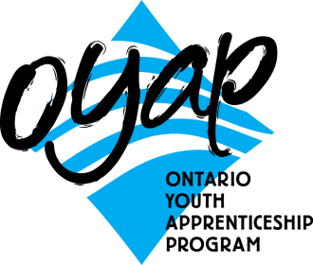
Ontario Youth Apprenticeship Program (OYAP)
The Ontario Youth Apprenticeship Program (OYAP) is a specialized co-operative education program that provides students with an opportunity to experience working in an apprenticeship sector. Students may choose to pursue an apprenticeship in a skilled trade while completing their Ontario Secondary School Diploma requirements. OYAP students will receive an OYAP certificate for completion of the Grade 11 and / or Grade 12 co-operative education courses.

Where is OYAP available?
OYAP is available at any WRDSB secondary school.

At what grade level is OYAP available?
Students may enroll in an OYAP program in either Grade 11 or Grade 12.

OYAP Program Requirements
Students must:
• be enrolled as a full-time student during the program must have completed the related in-school sector course
• have successfully completed all 16 Grade 9 and Grade 10 credits prior to the start of the OYAP program
• be 16 years of age or older
• have an acceptable attendance record
• be responsible for their own transportation to and from the placement worksite
• obtain Student Accident insurance through Reliable Life or provide proof that he/she and the OYAP school have adequate coverage
• complete an OYAP application form

OYAP Program Opportunities.
There are 2 OYAP pathway opportunities to support student career choices.
- OYAP Secondary School based program is delivered completely by the student’s home school and leads to apprenticeship opportunities through the regular apprenticeship process.

- College Delivered Apprenticeship Preparation Dual Credits
Students wishing to pursue their apprenticeship may choose the College Delivered Preparation Apprenticeship Dual Credit program in Grade 12. This program allows the student to work in their chosen sector and to complete 2 co-op credits and 2 college credits in their sector of choice at Conestoga College while earning their Ontario Secondary School Diploma requirements.
Apprenticeship Preparation credits will be applied to the first year college program in the related sector (e.g.- Automotive Service Technician, Cook, etc.)

College Delivered Apprenticeship Preparation Dual Credit Offerings:

College Program and Credit Availability | Course Codes
Automotive Service Technician - 2 college credits | OYAUTO
Early Childhood Education - 2 college credits | OYECED
Truck and Coach Technician - 2 college credits | OYTRUC
Cook – 2 college credits | OYCOOK
Welding – 2 college credits | OYMETL

For additional information, see your Guidance Counsellor or visit the website: goOYAP.com

E-Learning: Online Course Offerings

The following is general information about online learning. For additional course and/or registration information, please contact your guidance counsellor.

What is eLearning?
ELearning is a program delivery model that provides students with an opportunity to earn secondary school credits online. Students must be enrolled in a WRDSB secondary school during the time they are taking the course.

Why should I consider taking an eLearning course?
Online learning:
• Expands course availability and timetable flexibility (e.g., Provides access to courses that are otherwise unavailable due to timetable conflict, course not offered, or course enrolment full.)
• Provides an engaging, creative and interactive learning environment that may complement a student’s learning style
• Prepares students for online learning experiences in college, university and the world of work.

How do online courses work? Do I have to be online at a certain time?
The Waterloo Region District School Board online courses are designed to allow students to attend courses on days and at times that are convenient for them. There are set due dates for assignments and assessments, but students have the flexibility to complete assignments as their daily schedule permits. Attendance is taken on a weekly basis.

Is eLearning for me?
Students who have been successful in online learning typically have the following characteristics:
• Able to work independently
• Highly motivated
• Able to meet deadlines
• Comfortable using online technology
• Strong written communication skills

Frequently Asked Questions

What type of technology do I need?
Students will need regular access to a device with Internet access and software appropriate for the particular course. It is strongly recommended that students have access to a computer and the Internet at home.

How much does it cost?
There is no fee for students registered with the Waterloo Region District School Board.

How do I register to take an online course?
In order to register for an online course, students need to contact their school guidance counsellor or visit www.wrdsb.ca for more information.

Who teaches the course?
Certified Ontario teachers teach all of the credit courses offered through the online environment.

Will I be completely on my own?
No. Students will find that eLearning is very collaborative and provides many opportunities for discussion and sharing of ideas.

How will I receive a credit?
The student’s home school will grant the credits earned through the online environment.

How are tests taken?
Quizzes/tests, depending on the course, may be taken online or at the student’s home school, as arranged by the teacher. In some cases, final exams are written in the student’s home school.

Will I need a textbook or other material with my class?
Courses are designed so all materials are accessible online. There will be some particular software needed for specialized courses.

Where do I go to get help?
• Course help is available through the online teacher who will provide contact information at the beginning of each course.
• Course help is also available at the Student Success Centre at each student’s home school.
• Technical help is available through the online help desk and resources at the student’s home school.
• Login and password help is available by contacting your guidance counsellor.

What is the role of the parent in online learning?
The parent(s) should consult with the student’s guidance counsellor to determine if an online course is a good alternative to traditional learning. Parents should assist the student by encouraging active participation in the course, supporting the completion of assignments in a timely manner, and monitoring progress.

How does a student/parent contact a teacher?
ELearning teachers may be contacted by phone at the teacher’s home school. As well, the teacher is available by email or chat within the course.

•

E-Learning: Online Course Offerings

Grade 9
English | ENG1DE | English
 | ENG1PE | English
French | FSF1PE | Core French
Mathematics | MFM1PE | Foundations of Mathematics
 | MPM1DE | Principles of Mathematics
Guidance | GLS1OE | Learning Strategies 1
Science | SNC1DE | Science
 | SNC1PE | Science
 | Grade 10
Arts | ASM2OE | Media Arts
Business | BTT2OE | Information and Communication Technology
Canadian and World Studies | CHC2DE | Canadian History Since World War I
 | CHV2OE | Civics
 | CHV2OV | Civics (French Immersion)
English | ENG2DE | English
 | ENG2PE | English
Guidance and Career Education | GLC2OE | Career Studies
 | GLC2OF | Career Studies – French Immersion
 | GLD2OE | Discovering the Workplace
Mathematics | MPM2DE | Principles of Mathematics
 | MFM2PE | Foundations of Mathematics
Science | SNC2DE | Science
 | SNC2PE | Science
Technological Education | TGJ2OE | Communications Technology
Grade 11
Business | BAF3ME | Financial Accounting Fundamentals
 | BAI3EE | Accounting Essentials
 | BTA3OE | Information & Communication Technology
 | BDI3CE | Entrepreneurship
 | BMI3CE | Marketing
Canadian and World Studies | CGG3OE | Travel and Tourism
 | CLU3ME | Understanding Canadian Law
 | CLU3EE | Understanding Canadian Law
 | CGF3ME | Physical Geography (English or French Immersion)
 | CGT3EE | Geographer’s Toolkit
 | CGT3OE | Introduction to Spatial Technologies
 | CHA3UE | American History
Computer Science | ICS3CE | Computer Programming
 | ICS3UE | Computer Science
English | EMS3OE | Media Studies
 | ETC3ME | Canadian Literature
 | ENG3CE | English
 | ENG3EE | English
 | ENG3UE | English
Social Sciences and Humanities | HLS3OE | Housing and Home Design
 | HNC3CE | Understanding Fashion
 | HSP3UE | Introduction to Anthropology, Psychology, Sociology
 | HSP3CE | Introduction to Anthropology, Psychology, Sociology
 | HPC3OE | Raising Healthy Children
 | HRT3ME | World Religions
Mathematics | MBF3CE | Foundations for College
 | MCF3ME | Functions and Applications
 | MCR3UE | Functions
 | MEL3EE | Mathematics for Work and Everyday Life
Native Studies | NBV3EE | Aboriginal Studies
Physical Education and Health | PPZ3CE | Health for Life
Science | SBI3CE | Biology
 | SBI3UE | Biology
 | SCH3UE | Chemistry
 | SPH3UE | Physics
 | SVN3EE | Environmental Science
 | SVN3ME | Environmental Science
Technological Education | TGJ3ME | Communications Technology
Grade 12
Arts | AVI4ME | Visual Arts
Business | BAT4ME | Accounting
 | BBB4ME | International Business
 | BDV4CE | Entrepreneurship
 | BOH4ME | Business Leadership
 | BTX4EE | Information and Communication Technology
Canadian and World Studies | CGR4ME | Environment & Resource Management
 | CGR4EE | Environment & Resource Management
 | CHI4UE | Canada: History, Identity, Culture
 | CHY4UE | World History
 | CIA4UE | Economic Issues
 | CGW4UE | Canadian and World Issues
 | CLN4UE | Law
Computer Science | ICS4CE | Computer Programming
 | ICS4UE | Computer Science
English | ENG4CE | English
 | ENG4EE | English
 | ENG4UE | English
 | EBT4OE | Business and Technological Communication
 | ETS4UE | Studies in Literature
 | EWC4CE | Writer’s Craft
 | EWC4UE | Writer’s Craft
 | OLC4OE | Ontario Secondary School Literacy Course
French | FSF4UE | Core French
Mathematics | MAP4CE | Foundations for College Math
 | MCV 4UE | Calculus and Vectors
 | MEL4EE | Mathematics for Work and Everyday Life
 | MHF4UE | Advanced Functions
 | MCT4CE | Mathematics for College Technology
 | MDM4UE | Data Management
Science | SBI4UE | Biology
 | SCH4CE | Chemistry
 | SCH4UE | Chemistry
 | SES4UE | Earth and Space Science
 | SNC4ME | Science
 | SPH4CE | Physics
 | SPH4UE | Physics
Social Sciences and Humanities | HHS4UE | Families in Canada
 | HHS4CE | Families in Canada
 | HIP4OE | Personal Life Management
 | HNB4ME | The World of Fashion
 | HSB4UE | Challenge and Change in Society
 | HSC4ME | World Cultures
 | HZT4UE | Philosophy: Questions and Theories
Technological Education | TGJ4ME | Communications Technology
** Subject to availability.

