 **Brigadoon School Council** 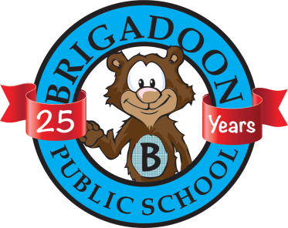

**Agenda**

**September 25th, 2017**

1. Principal’s September Update – Kelly Gudas, Principal [Kelly_Gudas@wrdsb.on.ca](mailto:Kelly_Gudas@wrdsb.on.ca)
2. School Council Update – Dijana, Guleren & Rachel. Over the summer…update. Budget. First fundraising popcorn sale was on Sept. 21st. Next popcorn day is Friday, October 13th during second break.
3. Brigadoon’s Volunteer Opportunities 2017/2018. Thank you to our First Day of School Meeter/Greeters. Looking for Popcorn Day Volunteers, Strong Start Volunteers for this Fall/Spring, Move & Groove-a-thon Volunteers, School Council Chair/ Treasurer/ Minute Taker, Pumpkin Carving Contest Organizer, Yearbook Volunteers, Angel Tree Volunteers, Newsletter Volunteers, Spring Fair Volunteers, Brigadoon Public School 25th Anniversary Committee.
4. Math Night (PRO Grant) application submitted – Thank you Kathy Gogos. Successful first time Family Math Night. Feedback? Would you like a family math night this year? Any other ideas or suggestions?
5. Spring Fair : Thursday, May 31st, 2018 – Jennifer Bramhill. Re-cap of 2017 Spring Fair and info for the Anniversary Spring Fair.
6. 25th Anniversary Committee
7. Peace Garden Project. Fall clean-up crew needed.
8. Yearbook – Jen Haves & Kathy Gogos.
9. Communication: Link for School Events Calendar for 2017/2018.
10. Other Business
11. Next School Council Meeting will be on October 23rd, 2017 at 7:00 p.m. in the library. Add the date to your calendar now.

*Please note that any topic suggestions may be forwarded to our school council chairs or to Kelly Gudas, your school principal. Looking forward to seeing you at school council!



Dijana & Guleren

Co-Chairs, Brigadoon School Council 2015/2017

brigadoonschoolcouncil@gmail.com