Draw the alphabet letters in a line and walk on each letter while singing the alphabet song. Or try having your child call out each letter as he/she jumps from one letter to another.

[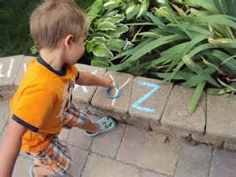](https://www.bing.com/images/search?q=alphabet+games+with+sidewalk+chalk&view=detailv2&&id=77D6D228E6FF795A4AF453EEA896EA02B23EE97E&selectedIndex=16&ccid=XJ1Aw0jE&simid=608009100509841834&thid=OIP.M5c9d40c348c473cfa05f760304d44de3o0)

**Tic-Tac-Toe**….draw a tic-tac-toe board with your sidewalk chalk on the ground. Use beans bags , pinecones or rocks as markers and take turns trying to make a tic-tac-toe.

[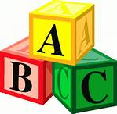](http://www.bing.com/images/search?q=clipart+abc&qpvt=clipart+abc&FORM=IGRE#view=detail&id=37D97D803B0614D50B97EDA7C49768B0F830E4F2&selectedIndex=0)

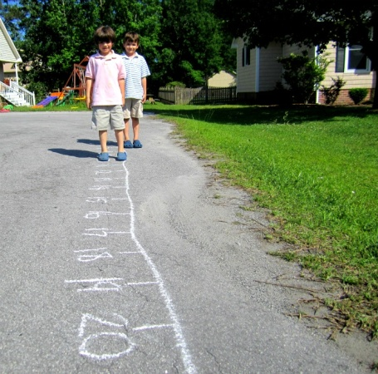 [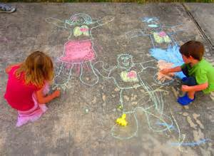](https://www.bing.com/images/search?q=body+tracing+with+sidewalk+chalk&view=detailv2&&id=B6B9717C04D3273E35C278AEABAD1B6F86CDEBDB&selectedIndex=26&ccid=EzWq7ZHN&simid=608022539454515633&thid=OIP.M1335aaed91cdf887c2d7258132426aa5o0)

Draw a number line and practice number line math. Start on 1 and take 2 steps, so 1+2=3 and so on. Change it up and see if your child can make their own math!

Have your child count their way up or down as they jump to the next number. Try calling out a number and tossing a bean bag to land on it.

[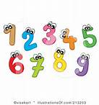](http://www.bing.com/images/search?q=Number+Clipart&FORM=RESTAB#view=detail&id=0D0C27A79BBAA39486C5F268F40B0BA94BC14977&selectedIndex=1)

Fine Motor FUN!!!

**Family Portraits’:** Personalize your sidewalk or driveway with portraits painted by your pint-sized Picasso. Use some colored chalk and have each member of the family draw a self-portrait or let each person draw a picture of someone else in your family. Don't forget to include your family pet!

**Creating City:** draw a city with buildings and roads to drive on. Make some bends and turns. Draw familiar buildings, such as, your home, school, local playground, grocery store and doctor's office. This will really get their creative juices flowing! Don’t forget to bring out the toy cars…

**Shadow Capture** : help build hand-eye coordination while learning about the sun and shadows. Use colorful chalk to outline the shadow of an object--a bike, or a favorite toy--then color in the outlines with your child. When the sun changes position, you'll have captured a shadow!

***Number Race, Number Jump!***

Draw large circles (or switch it up with different shapes) with a number inside it. Call out numbers at random and have your child race to that number and jump into the circle.

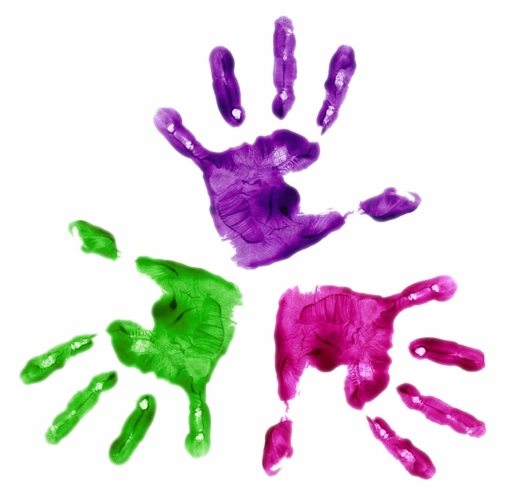

**Hopscotch Numbers:** Hopscotch is a fun way to follow the order of numbers as your child jumps from one to 10. Drawing circles verses the typical squares is much simpler and faster! Everyone can count as they jump along!