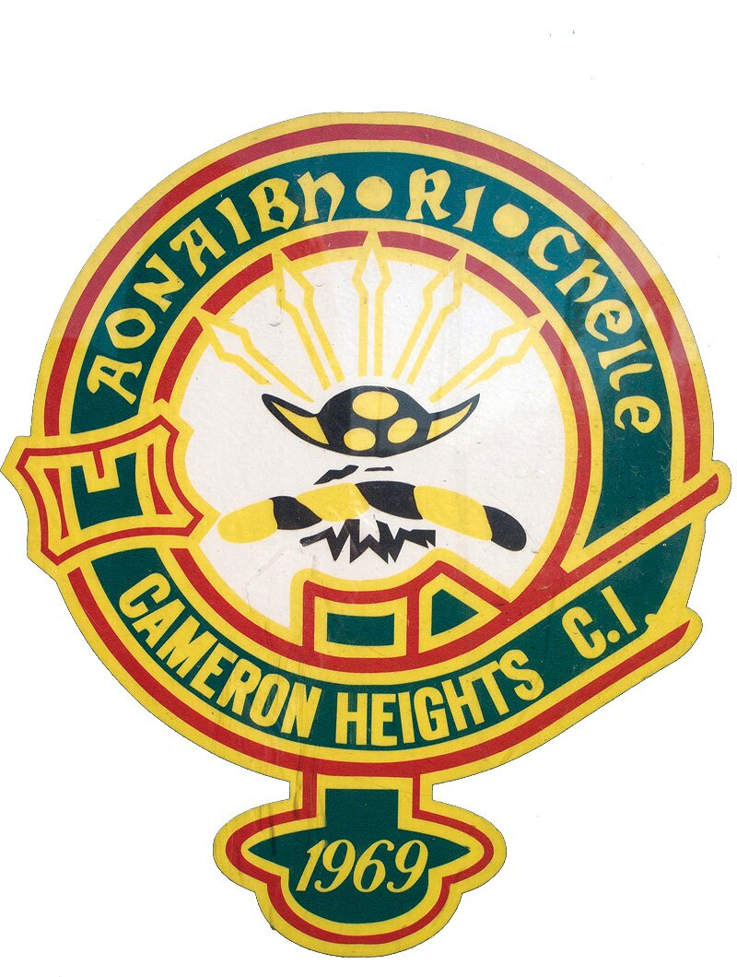
CHCI EVENTS OF THE WEEK

April 24th - 28th 2017

Date | Event
Monday April 24th 2017 | Community hours for the next OUAC and OCAS extract are due  Senior Boys Soccer vs FHCI @ Woodside 12:50pm  Girls Rugby @ University Stadium 1:30 pm  Check Out the Dodgeball Tournament in the Gym at Lunch!
Tuesday April 25th 2017 | GAME OF THE MONTH: Girls Soccer vs BCI @ Woodside 3:45 pm  Spring Concert #1: Peter's Lutheran Church, Kitchener 7 pm  Check Out the Dodgeball Tournament in the Gym at Lunch!
Wednesday April 26th 2017 | Habitat for Humanity Trip @ 8:15am to 2:15pm  Superior Court Field Trip @ Kitchener Courthouse, 8:15 to 1:15 pm  Senior Boys Soccer @ BCI 3:45 pm  Spring Concert #2: @ CHCI 7pm to 9pm  Check Out the Dodgeball Tournament in the Gym at Lunch!
Thursday April 27th 2017 | Superior Court Field Trip @ Kitchener Courthouse, 8:15 to 1:15 pm  Girls Soccer vs WCI @ Woodside 1:20 pm  Girls Rugby vs HHSS @ JHSS 1:30pm  Check Out the Dodgeball Tournament in the Gym at Lunch!
Friday March 25th 2017 | Check Out the Dodgeball Tournament in the Gym at Lunch!

