Assessments for the IB DP at CHCI
English A: Literature HL
Paper 1 Commentary 20%
Paper 2 Essay 25%
Written Assignment 25%
IOP 15%
IOC 15%
History of the Americas HL
Paper 1 DBQ 20%
Paper 2 WH Essays 25%
Paper 3 Americas Essays 35%
IA: Historical Investigation 20%

French B SL
Paper 1 Text Handling 25%
Paper 2 Writing 25%
Written Assignment. 20%
Individual Oral 20%
Interactive Oral 10%

Spanish Ab Initio SL
Paper 1 Text Handling 30%
Paper 2 Writing Exercise 25%
Written Assignment 20%
Individual Oral 25%

Psychology HL
Paper 1 Essay and questions 35%
Paper 2 Essays 25%
Paper 3 Questions 20%
IA: Study Report 20%

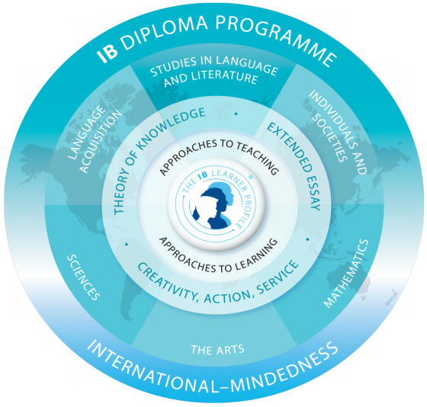
Biology HL
Paper 1 (MC) 20%
Paper 2 36%
Paper 3 24%
IA + Group 4 20%
Chemistry SL
Paper 1 (MC) 20%
Paper 2 40%
Paper 3 20%
IA: Investigation 20%
Mathematics SL
Paper 1 40%
Paper 2 40%
IA: Exploration 20%
ITGS SL
Paper 1 Responses 40%
Paper 2 Article 30%
IA: Written Report 30%
Chemistry HL
Paper 1 (MC) 20%
Paper 2 36%
Paper 3 24%
IA: Investigation 20%
Music SL
Listening Paper 30%
Musical Links Inv. 20%
Creating, Solo
or Group Performance 50%
Visual Arts SL
Comparative Study 20%
Process Portfolio 40%
IA: Exhibition 40%
Math Studies SL
Paper 1 40%
Paper 2 40%
IA: Project 20%
Physics SL
Paper 1 (MC) 20%
Paper 2 40%
Paper 3 20%
IA: Investigation 20%

