Ms. Mac’s Tips for Getting Good Grades

Notebooks/Binders
- Keep all notes in a binder (don’t use a coil-bound notebook- notes will get lost and out of order)
- Everyday HIGHLIGHT (not too much!) the key words of the lesson/note/worksheet
*This becomes the basis for your study notes for tests, quizzes and exams
- Ask yourself--- “What was the main/BIG idea?” (and can you answer the question)
- Correct answers in your notes, quizzes and tests- don’t let a wrong answer stay wrong!
- Start a ‘Study Page’ or ‘Cue Card ring’ for that topic/unit right away, and put key words/ideas on it… remember that LESS is more!

Study Tips
Studying IS NOT memorizing information! Though you may need to remember specific items, knowing “BIG IDEAS” is very important. Do you UNDERSTAND, and can you EXPLAIN?
- Use the ‘study page’ or ‘cue card ring’ (see above) to help prepare for testing- it really should have key words or ideas … POINT form is good, as this should just be a refresher/reminder for you.

Studying should not happen at the last minute (cramming). You need to have breaks for the information to ‘sink in’ and be sorted by the brain. Also, according to research there is a Curve of Forgetting, the loss of information we learn, which starts almost immediately.

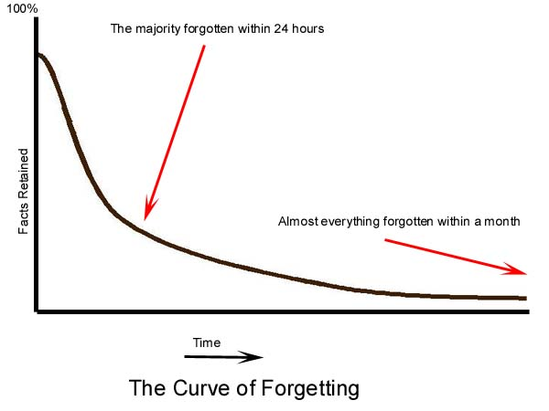
So, how can you remember?
Here's the formula to review material:
- Within 24 hours of getting the information - spend 10 minutes reviewing and you will raise the curve almost to 100% again.
- A week later (day 7), it only takes 5 minutes to "reactivate" the same material, and again raise the curve.
- By day 30, your brain will only need 2-4 minutes to give you the feedback.

Study Strategies
Acronyms use the first letters of concepts to create a word.
Acrostics use the first letters to create silly sentences.
Charting allows you to compare/contrast characteristics in an easy way.
Visualizing by drawing pictures, bolding or underlining words to help you ‘see’ them.
Story Linking takes ideas or concepts and creates a story by linking them together.
Mind Maps using words or pictures (try Smart Ideas on our school computer!)
Test yourself on the information- this can take many forms, but is very important because if you JUST READ over study notes, you can trick yourself into thinking that you know the information. How can you test yourself?
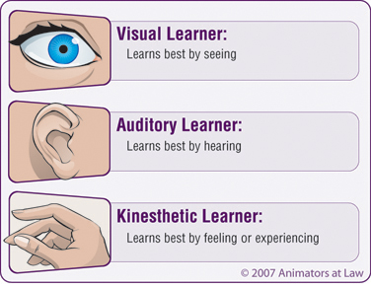 | Visual  - Think about what questions the teacher has/will ask? (see previous quizzes, text or worksheet questions) ANSWER these questions on a piece of paper or on the computer. ACTUALLY write it down- this forces your brain to work in a different way than just thinking inside your head.  - Get sticky notes and make mind maps that connect information and show you the ‘BIG PICTURE’. Put it on your wall, your door or closet.  - Make charts or use other organizers that help you make sense of the information.
Kinesthetic  PRACTICE what you need to know!  - Write out formulas.  - Put together technical parts, visit places or test science ideas…  - Find a way to ‘do’ what you need to explain! | Verbal/Auditory  - Take old quizzes and practice the answers.  - Have someone (friend, family member, etc.) ASK you questions about your sheets, cards, even your binder pages! EXPLAIN back to them the answers. They don’t have to know the information- it just should sound close to what is written on the page!  - Create a study group with others in your classes…get together and talk about what was learned, quiz yourself, etc.

Test Strategies for Different Types of Questions

Multiple Choice:
- Read the question and form an answer in your head before you look at the options.
- Stroke out obvious incorrect answers and choose from the rest.
- Take a chance-but make sure you pick an answer.

True/False:
- Watch out for words such as never, no, all, every, etc…
- Make an educated guess- try not to leave any blanks.

Fill-in-the-Blank: Never leave these empty- write something that seems logical.

Essay Questions:
- Organize or outline what you want to say before you begin to write. Taking just a few moments to plan will help you answer faster.
- Write down key words or ideas that you want to put into the answer.
- Get the most important things down on paper first, and then fill in the details.

