Manufacturing Employment Project
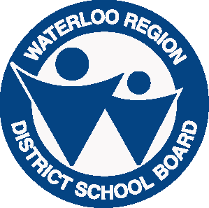
Connecting Students to Workplaces
Job Interview Request

ALL REQUESTS MUST BE RECEIVED BY 9am on Wednesday March 22nd ,
and MUST include an electronic copy of a resume

Please complete this form and return to: Tracey Kelly, Learning Services
Waterloo Region District School Board
Phone: 519-570-0003 X4539
FAX : 519-570-5560
E-mail: tracey_kelly@wrdsb.on.ca

Student Information (please type or print clearly)
Student Last Name: |  | Student First Name:
Home Address: |  | Email Address:
Home Phone #: |  | Cell Phone #:
All interviews will take place between 4pm and 8pm on Thursday, March 30th. All students will be expected to arrive at least one half hour before their first interview.
Sharing Contact Information: (required for participation)
I ______________________ (print name), understand that the above email/phone information only will be shared with our project partner, Employment Ontario, for the purpose of collecting feedback and making the student aware of other potential employment projects.

Signature __________________________ Date: _____________________
Signature is required - Student signature (18 yrs or older) OR Parent/Guardian (if student under 18 years of age)
School Information
School:
Teacher Contact/Moderator: |  |  | Teacher Signature:
The Teacher Contact in signing this form (or by forwarding this form via Waterworks) is agreeing to:
Verify that this student is completing their OSSD in June 2017 and will not be returning to school in the fall;
Verify that the student has Manufacturing or other “Hard Tech” experience (i.e. Automotive, Construction) either in the classroom, OYAP placement, or summer employment;
Confirm that the student is motivated and eager to learn;
Act as a contact for Tracey Kelly in confirming the student’s receipt of interview information
Please select the companies, in order of priority, for which you would like to have interviews.
First Choice: | Second Choice: |  |  | Third Choice:
Candidates will be contacted directly via email regarding interview times. All interviews will take place at the WRDSB Education Centre, 51 Ardelt Ave. in Kitchener on Thursday March 30th from 4-8pm. Students may not be interviewed for any or all positions in which they have expressed an interest.

