GRCI’s Course Selection Process for 2020/2021
MyWay Instructions
Step 1: Go to My Way (https://myway.wrdsb.ca/)

Step 2: Login using your school connect username and password.

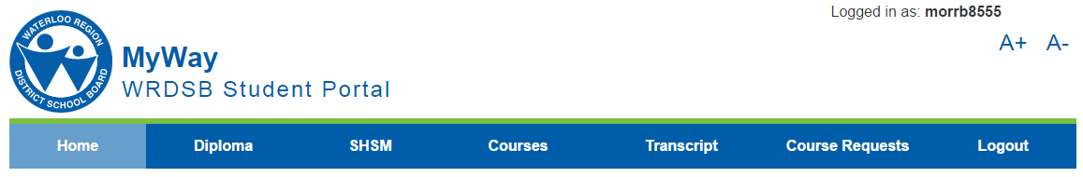
Step 3:

Choose the Course Request tab.

Step 4: Choose the appropriate options for you… Student destination
- I will be returning to this school
- I will be entering university in September
- I will be entering college in September
- I plan to enter college or university at a later time
- I will be going to work or starting an apprenticeship in September
- I will be moving to another School Board in September

Are you returning for a 5th year, semester 1 only?
If yes, please click on “other” and select Semester 1 Only (S1ONLY).

Click on “Next” Next

Step 5: Choose your courses from the Course Type: Regular Online E-Learning ….
drop-down menu. Grade: Grade 9 Grade 10 Grade 11 Grade 12

Course: ADA2OI – Open – Dramatic Arts Available Course

Click Add Course for each request Add Course

Step 6: When complete, PRINT your selections, have a parent sign it, and return it to school by February 18th.

Step 7: Logout (right side of menu bar)

Note: Remember to check www.grcicoursecalendar.weebly.com for course prerequisites and full descriptions.

