Panel 2

Describe the formation of the landscape in your area.

What interesting information is there about natural formations near your city?

Use diagrams and pictures to help describe the features.

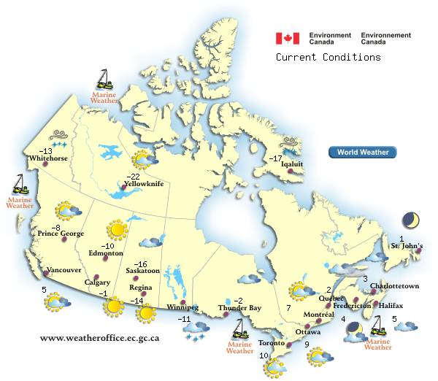
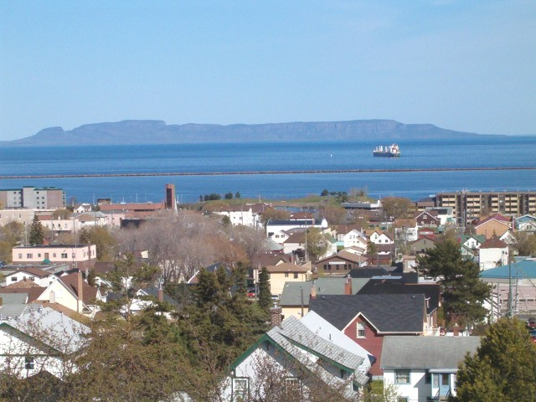

Be creative!!

Panel 3

The Climate!

Describe the climate…people want to know what to wear at what time of the year!

What are some of the factors that influence the climate?

Find a weather map…climate graphs…anything to add to the text!!

Panel 4

Wildlife and Vegetation

Describe the natural vegetation and give examples of wildlife unique to the region (Check the ecozone information!)

What impact have humans had on vegetation and wildlife? Look for introduction of new species.

Add some extras to your brochure!

Make it unique!



Panel 5
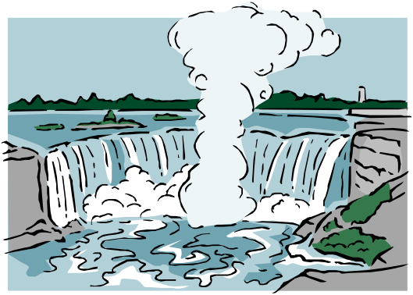
The Economy

On this panel describe the important economic activities that take place in and around your city.

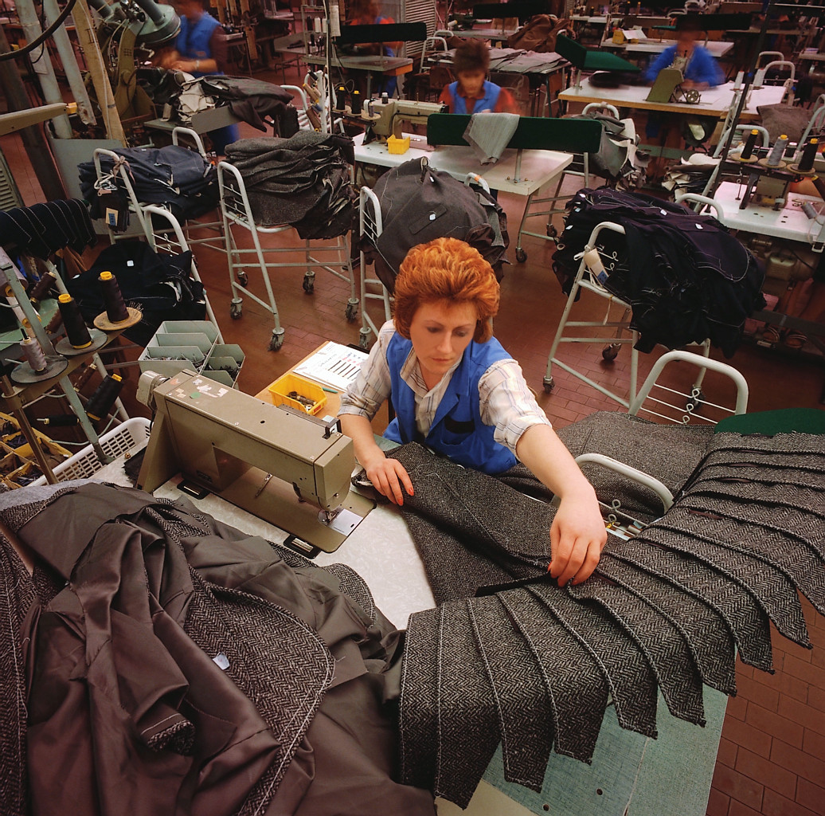
What are the main areas of employment?

What are the major tourist attractions?

Focus on the unique activities that you discover.
Panel 6

The Back Page!

Map Time
Place a map showing your city/region and its location within its ecozone

REFERENCES
List any sources you used for the information: web sites, books, notes.

Some useful sites:

Canadian Geographic
http://www.cangeo.ca/

Statistics Canada
http://www.statcan.ca/start.html

Huron Heights Library
http://hhss.wrdsb.on.ca/

Ecozone Site
http://www.ec.gc.ca/soer-ree/english/vignettes/terrestrial/terr.cfm

Also try to find a website produced by your city!

Panel 1

Your front cover!

Creating A Brochure of A Canadian City

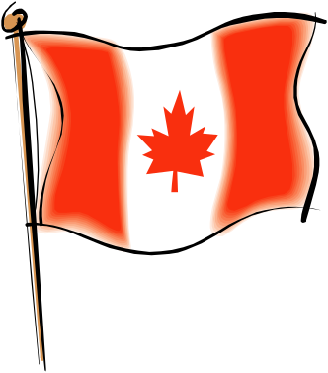

Name of City
Name of Student
4 images that highlight unique features of the area.

Tips:
- Be consistent…use the same font/style through the entire brochure.
- Make sure you research the right city!
- Make sure maps and images are useful
- Make your own climate graphs

