How to Access Videos: Learn360, NFB, and Curio (CBC)
Currently, you can access videos via the following sources with your PAL.
- Learn360 -- 10,000+ titles, 35,000+ video clips, speeches, images, and activities. Learn350 also houses an extensive list of commercial feature films.
- Curio (CBC) – News In Review from 1990 to 2014, an extensive collection of CBC-sponsored programs, different categories for browsing, and a searchable database.
- National Film Board (NFB) – a comprehensive collection of NFB’s films, searchable by title, subject or director.
- Each of the providers has its own search and browse feature. It’s fairly intuitive.
- There are two ways to access a video. If you know the title of the video you want, try Method 2 first. Method 1 is helpful if the video you want is new (2015) or if you want to browse the content available from Learn360, CBC or the NFB.
METHOD 1: Go to the Library Catalogue and login using your PAL. You can get to the catalogue via the Preston Library webpage. Click one of the icons. (see screenshot below)
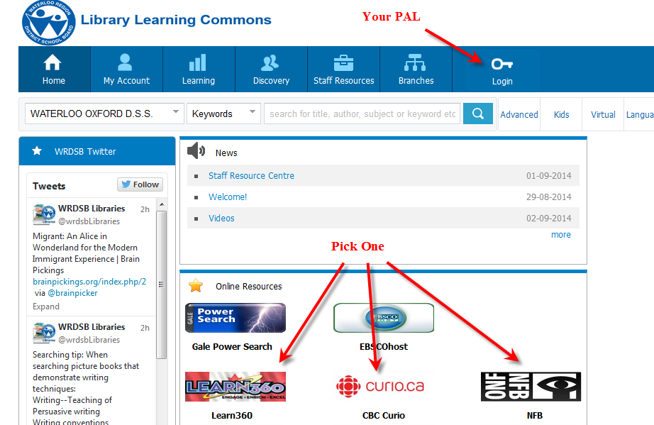

METHOD 2: Go to the Library Catalogue and login using your PAL. You can get to the catalogue via the Preston Library webpage. Change the location from Preston High School to eVideo Library and enter the search terms. (see screenshot below)
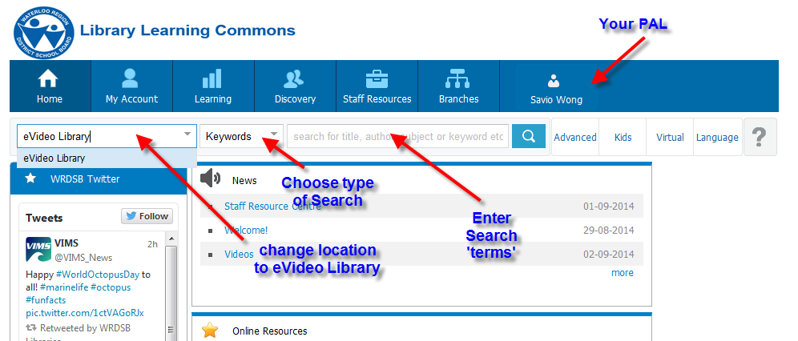
Once you enter the search, the results will appear on the next screen. The following were some of the matches when I did a search on China. By looking at the URL, you should be able to determine the source of the video. The no name is Learn360. Click on here the link is to view the video.
