 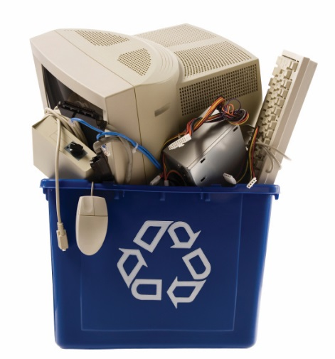

Accepted Items

**E-WASTE**

Scanners

Telephones

Televisions (all types)

Tuners

Turntables

Typewriters

UPS (Uninterruptible Power Supplies)

VCRs/DVD Players

Wires

*and More….*

*Call 416-222-1773*

*or email* [*info@revrecycling.com*](mailto:info@revrecycling.com)

*for more information*

Air Conditioners

Audio/Video Equipment

Batteries

Cameras

Cellphones

Circuit Boards

Computer Peripherals

Computer Parts

(processors, ram, etc.)

Copiers

Desktop Computers

Equalizers/Amplifiers

Hard Drives

Laptops

Microwaves

Modems

Monitors

Memory (RAM)

Network Equipment

Power Supplies

Printers

Receivers - Radio/Cable/Satellite

Servers

Speakers

Scanners