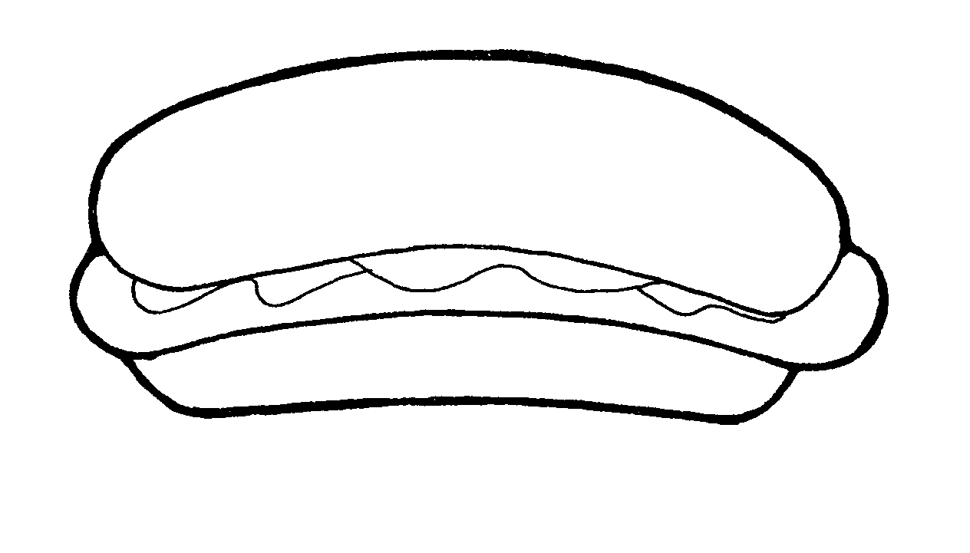



• DOOR PRIZE VALUED AT $100! FIELD GAMES!

DOOR PRIZE VALUED AT $100! FIELD GAMES!

Doon Public School invites you to its annual Spring BBQ. Enjoy good food, great company and fun activities!

Dinner for only $5! Includes drink, chips and your choice of hamburger, hot dog or vegetarian hamburger.

Doon PS
1401 Doon Village Road
Kitchener
519-748-1341
http://doo.wrdsb.ca

You’re invited to the
Doon BBQ
Thursday, May 26th, 2016
5:30 - 7:30 pm
Rain or Shine

• NEVER FORGET PHOTO BOOTH • CROSS FIT OBSTACLE COURSE

• NEVER FORGET PHOTO BOOTH • CROSS FIT OBSTACLE COURSE •

Tour your new school, meet some staff and make new friends! Parent information sessions held in the library at 6:00 & 6:40 pm.

