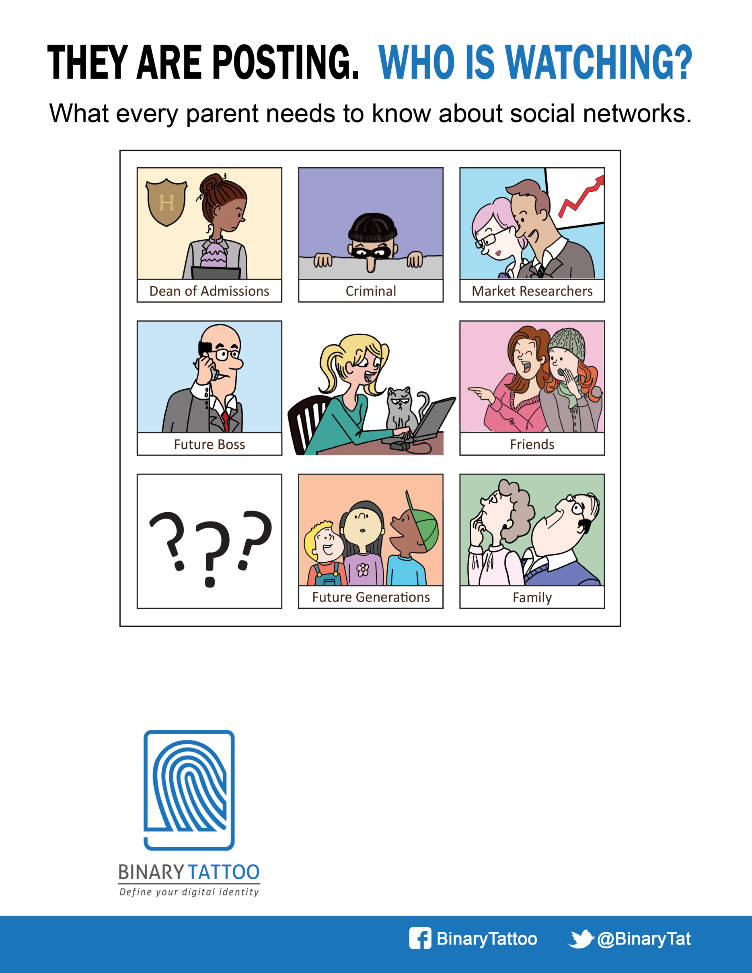

Can’t tell your Twitter from your Tumblr? Want to better understand what your child is using? Interested in protecting their posts from the wrong eyes? Join us for the answers to these and other questions for parents in the digital age.

SSafeguard Your Child’s Online Reputation

**Thursday, January 18, 2018**

7:00 p.m.

DOON PUBLIC SCHOOL

1401 Doon Village Road, Kitchener

For Tickets: www.binarytattoo.com