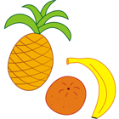
Healthy Tips for the Balanced School Day
Q: What is the Balanced School Day?
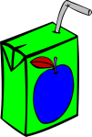
A: The school day is divided into three blocks with Nutrition Breaks in between.
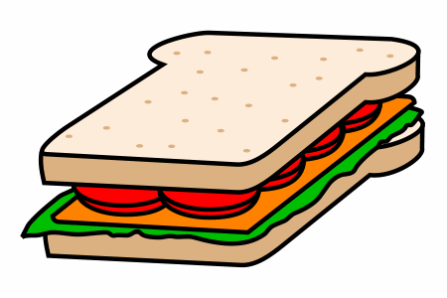
Arrival and Entry to school
Instructional Block ‘A’
Nutrition Break (20 minutes) followed by outdoor recess (20 minutes)
Instructional Block ‘B’
Nutrition Break (20 minutes) followed by outdoor recess (20 minutes)
Instructional Block ‘C’
Dismissal

The following ideas may help when packing food for your child:
- Thermos with spaghetti and sauce, macaroni and cheese, soup or oatmeal
- Raisins
- Granola bars
- Tortilla chips and salsa
- Pickles
- Pretzels, popcorn
- Water
- 100% juice (avoid cocktails, as these often contain added sugar)
- Cut up fruit & vegetables
- Tortilla wraps
- Applesauce
- Dried fruit
- Crackers with cut up meat and cheese
- Sandwiches
- Fruit cups
- Bagels, English muffins
- Cereal
- Rice cakes
- Pin Wheels
Kindergarten Shopping Suggestions
** We are a Peanut/Nut/Shellfish Free School **
Our school offers a lunch program and milk program. Items are purchased on a monthly basis through “School Day”, our on-line communication and payment tool.
Healthy Eating Tips for School:
- Please pack a nutritious lunch for our child, this will allow them to perform better
- Pack your child’s lunch together, discuss and plan what to eat during each break with your child. Consider labeling items “lunch 1” and “lunch 2”
- Please limit foods such as candy, fruit roll-ups, chips, sweet treats, etc.
- Please remember to unpack lunch containers and wash lunch bags periodically to avoid bacteria growth
- Prepare your child’s food so that they may be able to eat it without assistance (e.g., partially peel an orange, snap open the top of a banana)
- Please remember to pack eating utensils (spoon, fork)
- Please send enough food to keep your child fueled throughout the day at school. Consider sending additional snacks that may be eaten throughout the day, as many children are often hungry when they arrive at school
- Children may not share their lunch with classmates
Beginning Kindergarten is an exciting time for our child. Below are some suggestions that we would like you to consider when you are preparing for school. In Kindergarten, the children are encouraged to be independent and responsible for their own belongings. Please take into consideration the following ideas to make the transition easier for your child.
- Take your child with you when shopping for school items
- When buying shoes, have your child demonstrate for you how they can put them on independently (or with minimal coaching)
- Have your child try on their backpack (if you think that it looks too big for them, then it is the perfect size!)
- Have your child try on their snow pants/suits to see if they can get them on independently (avoid complicated clips/snaps)
- Help your child practice getting ready by leaving extra time when leaving your home to allow your child to put on their shoes and jacket independently.

To help your child be independent at school, please consider the following Do’s and Don’ts:
DO’s | DON’Ts
- Velcro or slip-on shoes and winter boots  - Running shoes (appropriate for physical activity)  - Coats with zippers  - Mittens  - Easy-on snow pants  - Big backpack  - Reusable lunch bag and containers  - Label your child’s belongings | - Shoes and boots with laces and zippers  - Dress shoes, slippers, boots and Crocs  - Coats with buttons or snaps  - Fingered gloves  - Snow pants with tricky snaps and clips  - Small backpack  - Disposable bags and containers

Please note: If your child will be attending the Extended Day Program, please be prepared to supply an additional change of clothes.
Your support is greatly appreciated! We look forward to getting to know you better and spending time with your child in September!
Blair Road Public School Kindergarten Team

