**Why are scissor skills important?**

Taking part in activities using scissors helps children develop muscles in their thumb, index finger, middle finger and wrist by opening and closing the blades of the scissors. Building and strengthening the small muscles in the hands are necessary for the manipulation of small objects.  
 Without these fine motor skills, performing tasks that require manual dexterity, such as learning to write, are more difficult.

**Grasp**

The most efficient grasp is the thumb in the top loop (thumbs are always pointed up) and the middle fingers are placed in the bottom loop ( middle, ring and pinky fingers; depending on the size of the hole) Placing the index finger in front of the bottom loop provides stabilization and directional guidance. Then begin to practice opening and closing the blades of the scissors.

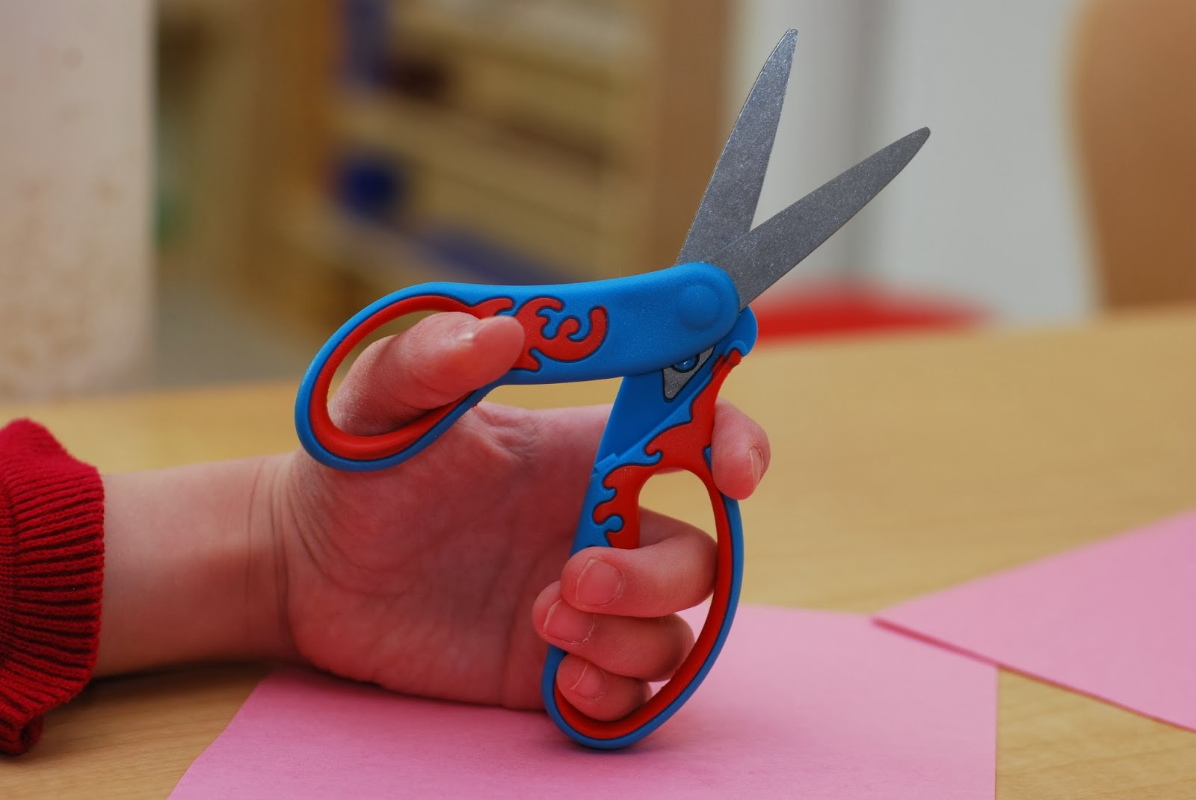

**Left-Handed Scissors**

For left handed children, invest in a pair of "lefty" scissors. The blades are attached in the opposite way and allow left-handed children to see the line they are cutting.

Let your child practice their cutting skills on a variety of different things such as textured paper, fabric, tin foil, drinking straws (they make a cool popping sound when cut!)….the possibilities are endless!

Include your child in the making of your family grocery list. Have them cut out the items from the store flyers and glue them onto a piece of paper.

When your child finishes colouring a page from a colouring book, have them cut out around the picture and then put it on display.

Give your child strips of coloured construction paper, about an inch wide, and show them how to snip through the strips to make them shorter. When they have cut several short strips of paper, give this cutting experience meaning by using the pieces to make a collage or picture by gluing them onto another sheet of paper.

Roll out playdough into “sausages” or “worms” and then snip them to make little “peas”.