Breslau Public School

November 2021 School Council Meeting

Meeting Details | Monday November 29, 2021 | 6:45PM Virtual
In Attendance; Parents | Alissa Bingeman, Carmin Lakhanpal (Co-Chair), Kristy Smith (Co-Chair), Roger Schamp, Liz Siddorn (Treasurer), Sonya Willsher (Secretary)
School | Michelle Schmid (Principal), Sherry Lawlor Alexander (Vice-Principal, Carey DeVrieze-LoRusso (Teacher Representative)

DISCUSSION NOTES
- Territorial Land Acknowledgement
- Welcome - Carmin
- Financial Report – Liz will update in January meeting; account currently sitting in excess of $18k
- Principal Report - Michelle/Sherry
  - Picture Day – scheduled for Jan. 18th. Paperwork and School Day will go out when school resumes.
  - Volunteers - Board worked through a process to get started with volunteers Strong Start and Nutrition for Learning program; looking to get all logistics in place by the break to start the Strong Start program (working with Taryn Wagner) in the new year
  - Ministry test kits - Sherry created class sets of testing kits to be sent home before break. More details to follow. The Ministry of Education will also require schools to verify that students have used the Ontario School Screening Tool daily for 2 weeks after the winter break.
  - New plan for recesses – Michelle and Sherry worked with Human Resources to hire additional supervision monitor (Bella). Bella has already started for both 40 min breaks. The new plan is one regular recess per class each day (20 mins outside, 20 mins inside for eating, and another 40 min break inside). Unable to offer both breaks outside due to lack of supervision or space for cohorting.
  - Staff learning focus (Sherry) – Start of the year, the board introduced a “DIRECT” tool that the School Board has launched to help mitigate, and mediate discrimination concerns and issues raised. (see screen capture at bottom)
Historically, educators and families were not sure how best to approach and intervene for students who are experiencing discrimination. This tool is essentially a process for staff and students to address the issue, to ensure family’s needs are heard, addressed, and met, as well as to ensure help to the offenders.
There are posters for each class, and the staff is working with students to understand the process (in an age-appropriate way). ACTION: Sherry to send or link to poster with additional links
In BPS specifically, they have determined that students need some social development support, especially in this second year of pandemic. The staff has continued to work on incorporating Trauma-Informed Learning, and understanding social cues. The school’s social worker is providing ongoing professional development at staff meetings and board social worker (1 session has happened with the teachers, with 3 more modules).
At every grade, the kids are struggling with this and playing safely. There is a real impact on the brain which can disrupt learning, and can cause thinking to be less reflective.
Also to help with this, a teacher is working on a Social/Emotional learning program at BPS. The school board is also supported through PD online and supported by a school psychologist. Staff are working with students on how to co-regulate, be predictable, establish connections, be flexible and help them to better understand and promote well-being. Topics covered included:
- What to expect of a friend vs a friendly classmate?
- How to talk through a disagreement or conflict.
- What is civility?
- Working to establish a class agreement to set expectations for supportive group interactions

- Staff Report – Carey DeVrieze-LoRusso
  - Recess commentary:
    - Primary teachers – starting to get the hang of going outside and it’s going well.
    - Intermediate teacher – ability to go outside has been positive.
  - Intermediate dodgeball is underway (60 kids participating). Next is either basketball or volleyball (Tanya Hagerty considering which to move forward with.)
  - Winter class competition (“Minute to win it”)
  - Grade 7s are considering working with Woolwich Township to collect for hampers. It is still under review given Covid restrictions, limiting exposure and requirements.
  - Home reading has been successful and is growing steadily.
  - Indoor shoes are a must with the changing weather.

- BPS By Laws – Kristy/Carmin | Adoption of By Laws by consensus: agreed to adopt with changes noted below.
    - Changes noted and agreed to:
      - Page 5 – Update with 2021/2022 School Council membership
      - Page 10 – Adjusted phrase “plan and present an annual budget”
      - Page 12 – Minutes will be hosted on Google Drive for input, comments, and revisions.

- Fundraising update – Michelle
  - Continue to expect to receive more information around fundraising guidelines under covid protocols.
  - There were some guidelines around the number of people and interactions that fundraising activities bring to the school. We need to ensure risks for Covid transmission are mitigated: requires reduced contact and interaction of visitors on-site; therefore, staff need to be responsible for transporting, with staff required to wear medical masks and anything collected will not be on display. ACTION: Michelle to add links to the guidelines once they are provided by the board

- 2021/2022 Council Initiatives – Kristy – Need to Map out where to invest $18k in funds
  - Discussed and agreed that a primary focus for this upcoming year(s) will be on Improving Outdoor Space.
    - Areas of focus discussed include the Naturalization area, Outdoor classroom, new Gaga Ball Pit, refreshing outdoor equipment.
      - Areas explored late last year include:
        - In Courtyard, the structures need to be replaced, with possible mud table/outdoor kitchen and stumps to sit and play (exploratory items) .
        - In the earmarked outdoor classroom area, there was a quote with big stones and mulch in the middle to help with instruction (Preliminary budget fell between $32k - $51k), ACTION: Carmen will share options to this group to understand options presented and relative costs.
        - Roger raised a covered outdoor classroom space possibility similar to the one outside the Community Centre.
        - Sherry noted that some of the trees need some TLC and the possibility of adding some more in spaces which receive little shade.
        - Fields 3 and 4: Other side of the path is a priority area for development. Liz raised the possibility of adding outdoor exercise equipment (e.g. balance beams, more active space)
      - To move forward, we need:
        - To confirm if a list of approved vendors exists. Earthscapes has done work for other schools but there may be others who have worked with schools. ACTION: Michelle to check with Grounds/Facilities team(s) to see if they have any approved vendor list, recommendations, and/or if there is a process for hiring or vendor to work with.

        - To identify which staff is interested in forming a committee to guide what they would like to see in an outdoor classroom and other spaces. ACTION: Michelle to follow-up with staff, set up a time to meet virtually. Kristy has volunteered to be a liaison with this group. Michelle to confirm and set up a time to start to move forward by meeting virtually

- ACTION: For larger team, January meeting - review list provided by Michelle will send on fundraising initiatives to see safety criteria must be met, and additional considerations/options to discuss.

Next Parent Council Meeting scheduled for January 24, 2022.
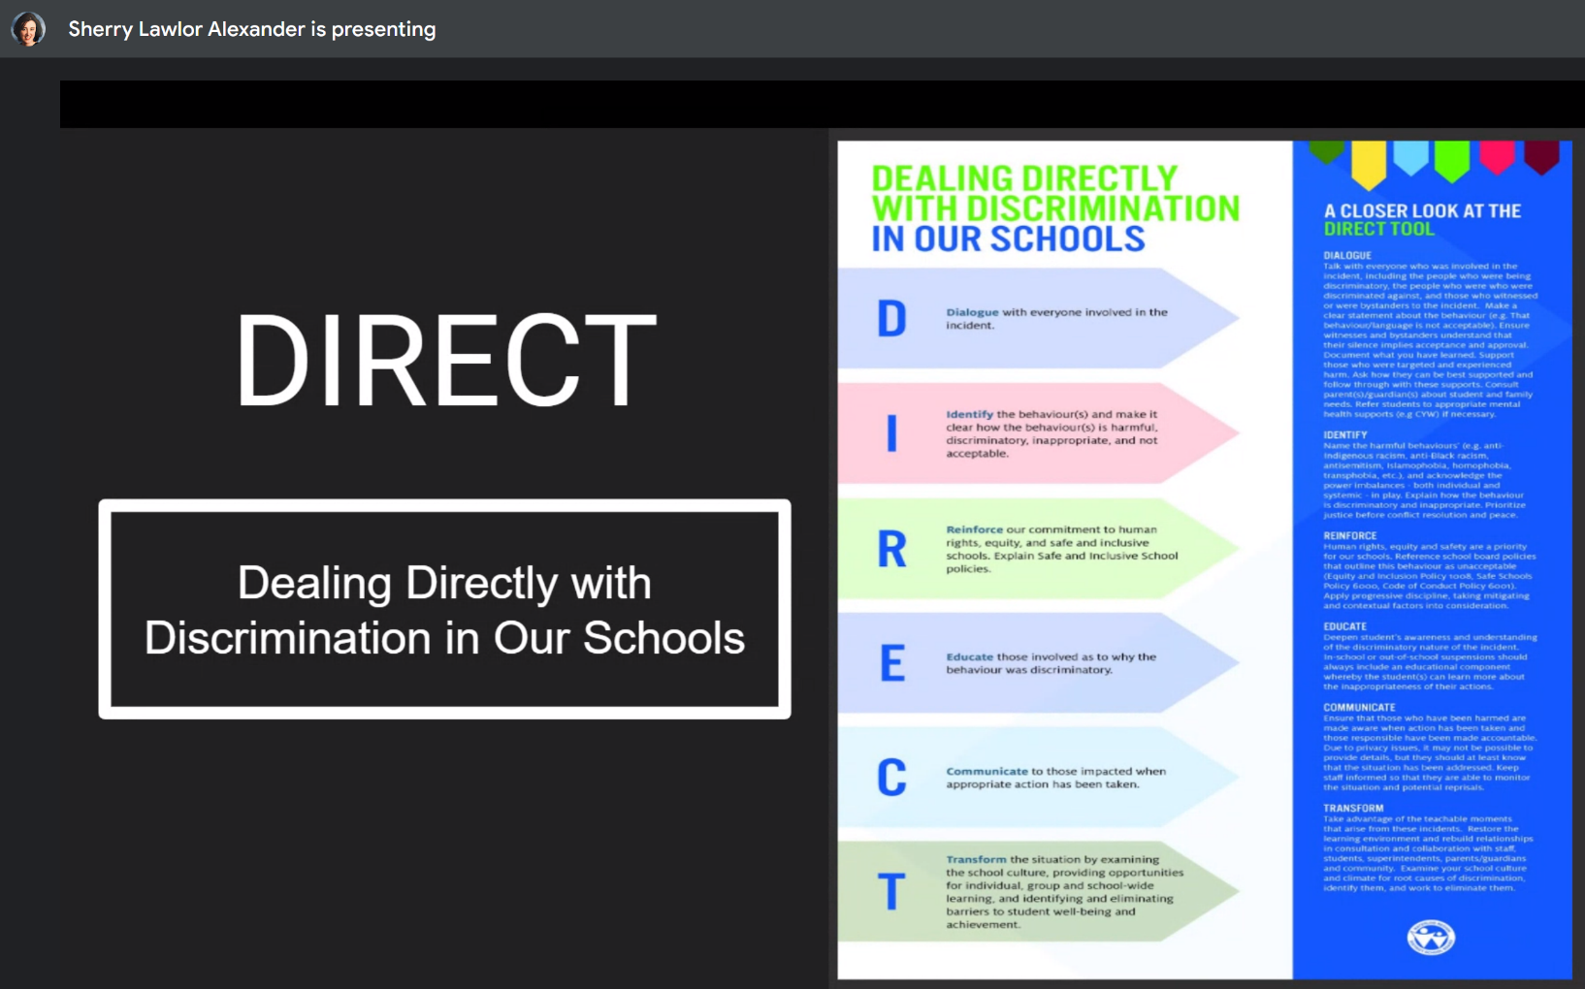

TI%20Poster%20(4).pdf

