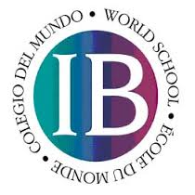

Failing Conditions for the IB Diploma

It is the responsibility of the IB students and their parents to become familiar with the codes of conduct and regulations that govern IB schools. These responsibilities can be found on the Cameron Heights website, under the IB tab, in the “For Parents” section (http://chc.wrdsb.ca/ib/for-parents/).

The following codes are in effect from the May 2015 examination session, onward.

From the May 2015 session the following failing conditions and associated codes will replace those in current use.

1. CAS requirements have not been met.
2. Candidate’s total points are fewer than 24.
3. An N has been given for theory of knowledge, extended essay or for a contributing subject.
4. A grade E has been awarded for one or both of theory of knowledge and the extended essay.
5. There is a grade 1 awarded in a subject/level.
6. Grade 2 has been awarded three or more times (HL or SL).
7. Grade 3 or below has been awarded four or more times (HL or SL).
8. Candidate has gained fewer than 12 points on HL subjects (for candidates who register for four HL subjects, the three highest grades count).
9. Candidate has gained fewer than 9 points on SL subjects (candidates who register for two SL subjects must gain at least 5 points at SL).

