INVITES ALL FUTURE
GRADE 7 STUDENTS & THEIR FAMILIES
TO OUR GRADE SIX
ORIENTATION EVENING
Thursday, May 23rd
6:30 - 7:30 PM (Doors open at 6:15 PM)

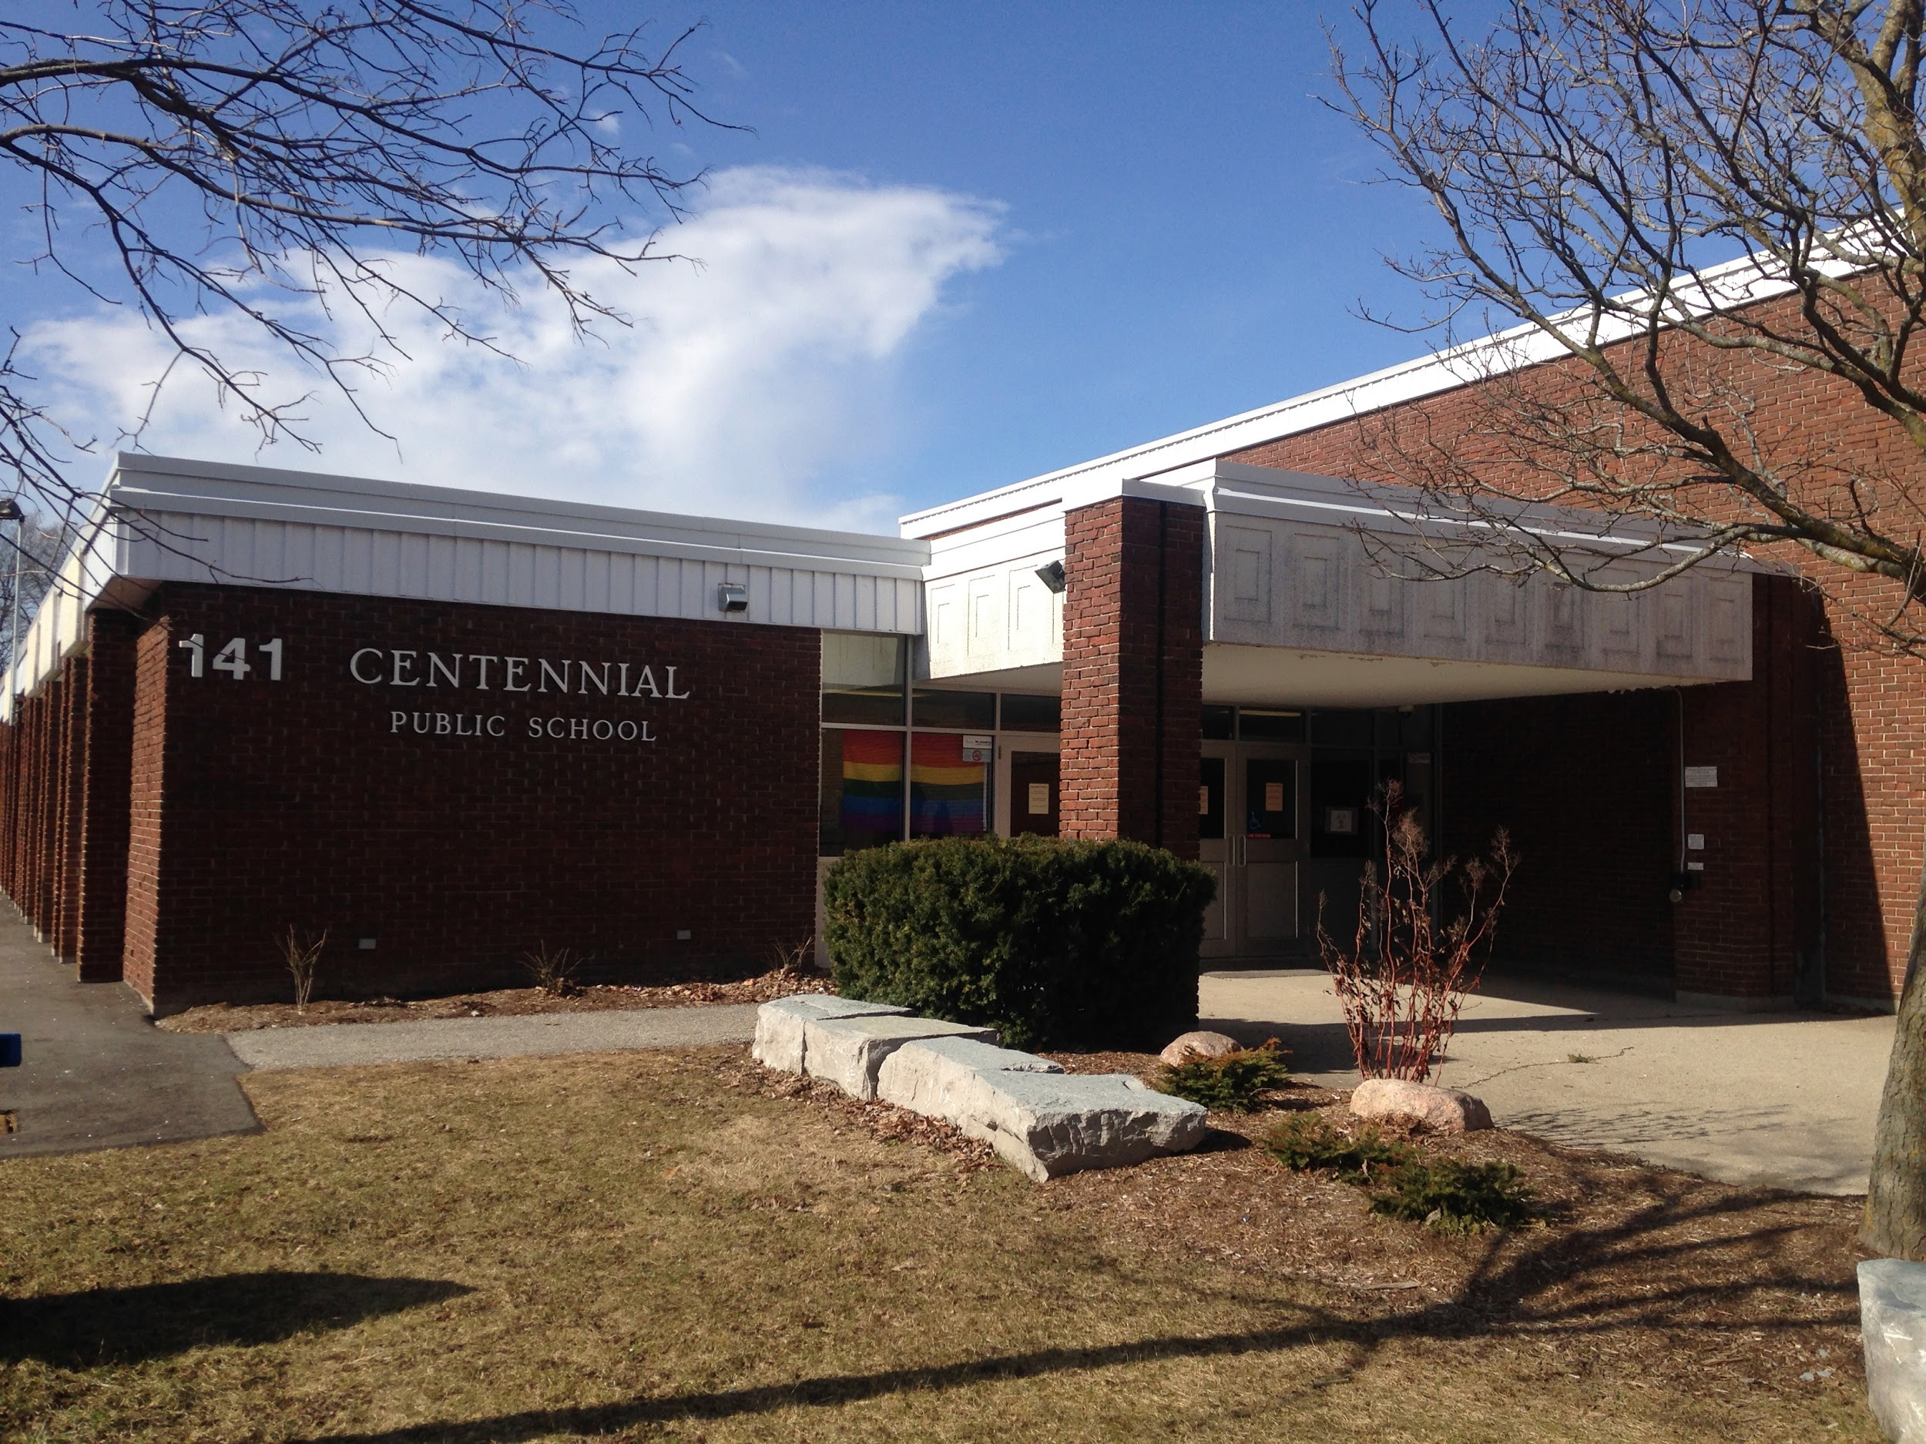
This evening is for students AND their families to learn about
the coming 2019-2020 school year,
and our academic and extra-curricular programs.

Come and enjoy a tour of YOUR new school!

