Wednesday, December 18, 2013

Dear Parents/Guardians:

RE: Service Dog at School

Beginning on January 15th, 2014 one of our Doon Students in grade eight (from our Room 12 Congregated Class) will be attending school accompanied with a Service Dog (from National Service Dogs) to support his learning needs. Successful transition and entry of the dog into the school environment has been planned in accordance with the Waterloo Region District School Board Use of a Service Dog by a Student Procedure and with input and consultation from the school and broader community.

The dog has been specially trained and is a Certified Service Dog in accordance with the guidelines established through National Service Dogs. This is a working dog and will be easily identified by the vest it wears. Students will be introduced to the dog at a school assembly at which time expectations and rules for interaction with the dog will be reviewed. Working dogs should not be petted or approached without the permission of the dog’s handler.

Should you wish further information or would like to speak further about the entry of a service dog into the school setting, please do not hesitate to contact the school directly.

Sincerely,
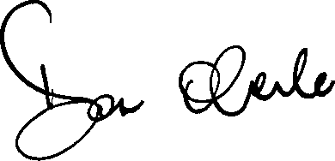
Mr. D. Oberle

Principal

cc: Mrs. L. Hodgins, Superintendent of Education

