Interesting Vocalist -
PETER CETERA

- Born on September 13, 1944 in Chicago, Illinois
- Second of six children, two of whom became musicians
- Interest in music began at age 11 when he was given an
accordion, instead of a guitar like he had wanted
- Bought a guitar at age 15 after seeing a live band perform at a club, and shortly
afterwards, started singing lead vocals and playing bass for his first band
- Joined the rock band Chicago in 1967

Chicago
- One of three vocalists in the group, singing lead on only one song on debut album
- “25 or 6 to 4” was the band’s first major hit single to feature Cetera on lead
vocals, earning him a more prominent vocal position within the band
- Sang lead vocals on 11 of the band’s 21 top-10 singles, as well as writing the
majority of the band’s ballads, leading to their titular “ballad band” phase
- Unofficial leader of the band from 1978 to his departure in 1985
- Cetera continues to sing as a solo performer with 6 top-40 singles of his own
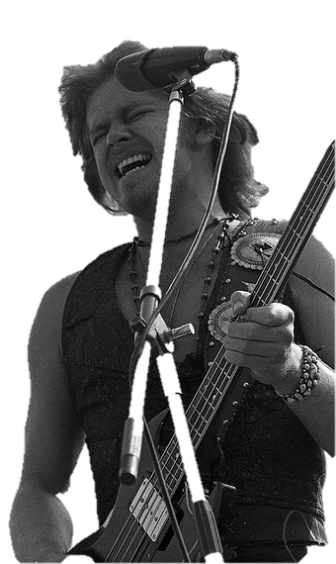
The Voice
"Four marines didn't like a long-haired rock 'n' roller in a baseball park, and of
course I was a Cub fan, and I was in Dodger Stadium, and that didn't do so
well. I got in a fight and got a broken jaw in three places, and I was in
intensive care for a couple of days. The only funny thing I can think about
the whole incident is that, with my jaw wired together, I actually went on the
road, and I was actually singing through my clenched jaw, which, to this day,
is still the way I sing."

- After having to sing with a wired-shut jaw, Cetera learned how to modify his
technique to adjust the new shape of his mouth, giving him his signature sound
- Limited level of openness in the jaw creates less resonance, but a bright
tone created by his naturally high timbre and fixed smile while singing
- Vocal placement centers around the front of the mouth, not in the
nose, creating a “cutting” sound dude to its great shape for projection
- Fully supported in the diaphragm, with no straining in the throat
seen or heard on vocal recordings or videos
- Range has lowered over the years due to his age and lack of formal
training, yet his identifiable sound still remains intact

Listening examples: “25 or 6 to 4” (1970)
“If You Leave Me Now” (1977)

