Interesting Vocalist- Andrea Bocelli Laura Burjoski

Biography
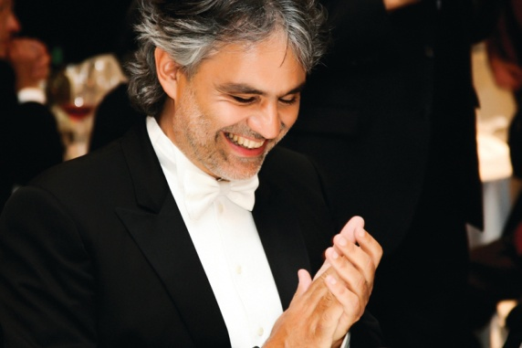
Andrea Bocelli was born on September 22nd, 1958 in Lajatico, Italy. He grew up on his family farm, selling farm machinery and making wine. He has always had a zeal for music, even from a very young age. His mother says that as a young boy, the only thing that would soothe Bocelli was music. He started piano lessons when he was six years old, and later began to study trumpet, trombone, saxophone, flute, guitar and drums. He was first introduced to opera at a very young age, and by the time he was seven he could identify and recognize the voices of multiple famous opera singers, as well as emulate them. At the age of twelve, he lost his sight during a football game, and the doctors, despite their great efforts, could not retrieve it, leaving him permanently blind. Bocelli graduated high school in 1980, and then went on to study law at the University of Pisa. Throughout his university education, he continued to study music on the side. He then realized that opera was his passion, and began to pursue that.

Success
Throughout his career, Bocelli has received dozens of awards and honors, including a World Music Award for “World’s Best-Selling Classical Artist” in 2010, and titles such as Album of the Year, Best Italian Artist, and Outstanding Contribution to Music.

Con Te Partirò
Written and produced in 1996, and is by far Bocelli’s most popular and well known song to date. He released this song as a duet with Sarah Brightman, and almost immediately it became a top played song all over the world. The duet became the best selling single of all time in Germany.
The title of the song translates in English to “I’ll Go with You”.

Voice
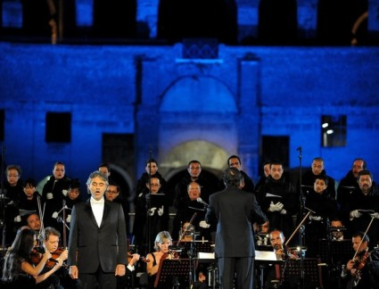
Bocelli has a classical tenor voice, though he sometimes performs songs of a more pop nature. He has a voice similar to those who sang Bel Canto at the time that it was written. He can sing G’s and Ab’s in his full chest voice, and after that he uses a mixed head and chest voice, not falsetto. Some people argue that he doesn’t have a “real” opera voice, because his voice doesn’t amplify naturally over a full orchestra. People coming from a non-opera background do not recognize the difference; however he cannot technically be classified as an “opera singer” because of it. Another interesting thing to note about Bocelli’s performance is because of his visual impairment, he cannot see the conductor, which means he performs all of his entrances by ear.

