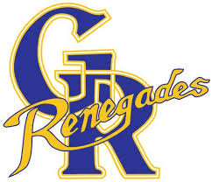**Grand River Collegiate School Council Presents**

**Mental Health Information Speaker Series**



**SESSION 1 – March 21, 2018 – Substance use and Mental Health**

Ray of Hope will provide information on different aspects of drug use including types of drugs, coping, harm reduction, suspect use, programs and options.

Register - <https://grandriveryouthdrugs.eventbrite.ca>

**SESSION 2 – April 19, 2018 –– Youth Mental Health and Wellness**

Canadian Mental Health Association will speak about teen mental health and what to do if you suspect that your teen needs help.

Register - <https://grandrivermentalhealth.eventbrite.ca>

**SESSION 3 – May 9, 2018 – safe TALK Workshop**

**safe TALK** is a ***three-hour training program*** that prepares helpers to identify persons with thoughts of suicide and connect them to suicide first aid resources.

Register - <https://grandriversafetalk.eventbrite.ca>

All sessions will be held in the Grand River Collegiate Lecture Hall and begin at 6:00.

For more information contact Sue Hallman-Rose at GRCI Guidance or GRCI Parent Council.

GRCI School Council welcomes all parents to join us for information on teen mental health and substance abuse in our community.

Please **register** for the sessions you wish to attend using the links below.