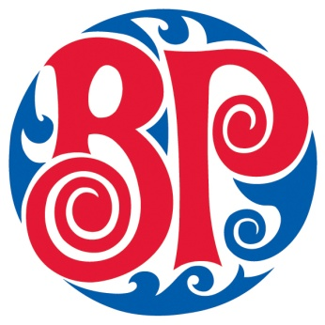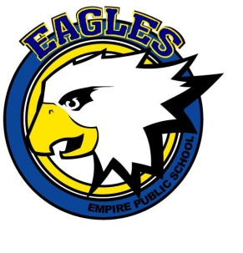

Boston Pizza Erbsville & Empire Public School
are having a FUNDRAISER!

Monday November 27th, 2017

10% of the sales from 5pm-8pm
Will be donated to Empire Public School to help them reach their fundraising goal to purchase ceiling mounted projectors and technology.

Location: Boston Pizza Erbsville
651 Erb Street West, Waterloo

IMPORTANT!
“BRING THIS FLYER WITH YOU”

Help Support one of our Local Grass Roots Public Schools

Strongly recommend reservations please call or send an email to
519-747-8000 or bperbsville562@gmail.com
Follow us on Twitter @BostonPizzaKW
https://www.facebook.com/BostonPizzaErbsville

