**SES4UI: Earth’s Surfaces and Processes**

**Groundwater:  
Explore, Understand, and Protect**

**Program Summary and Curriculum Connections**

**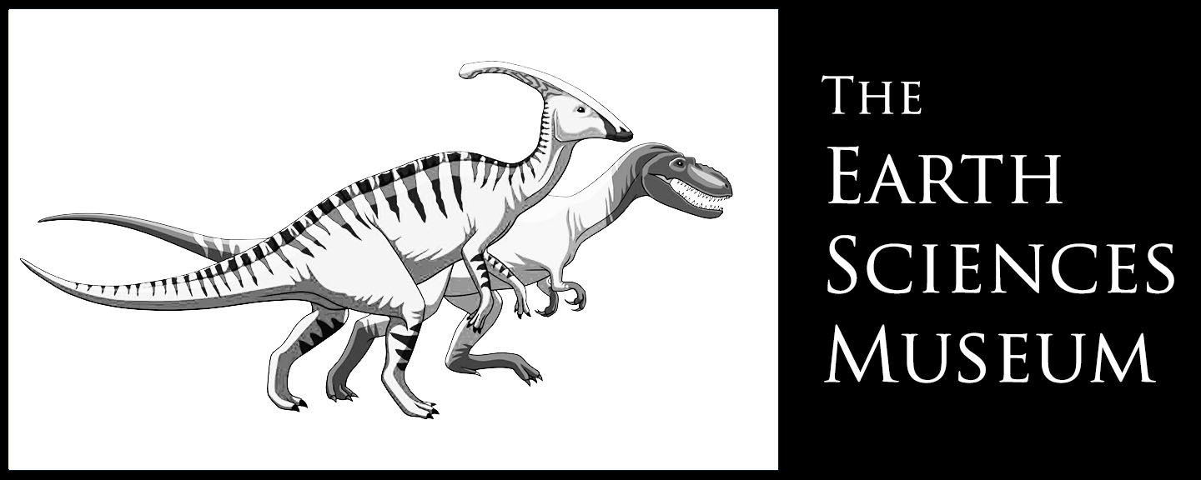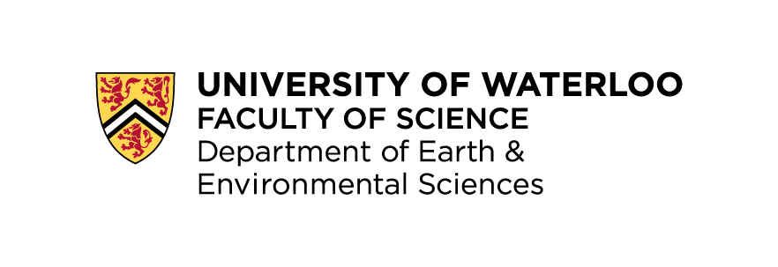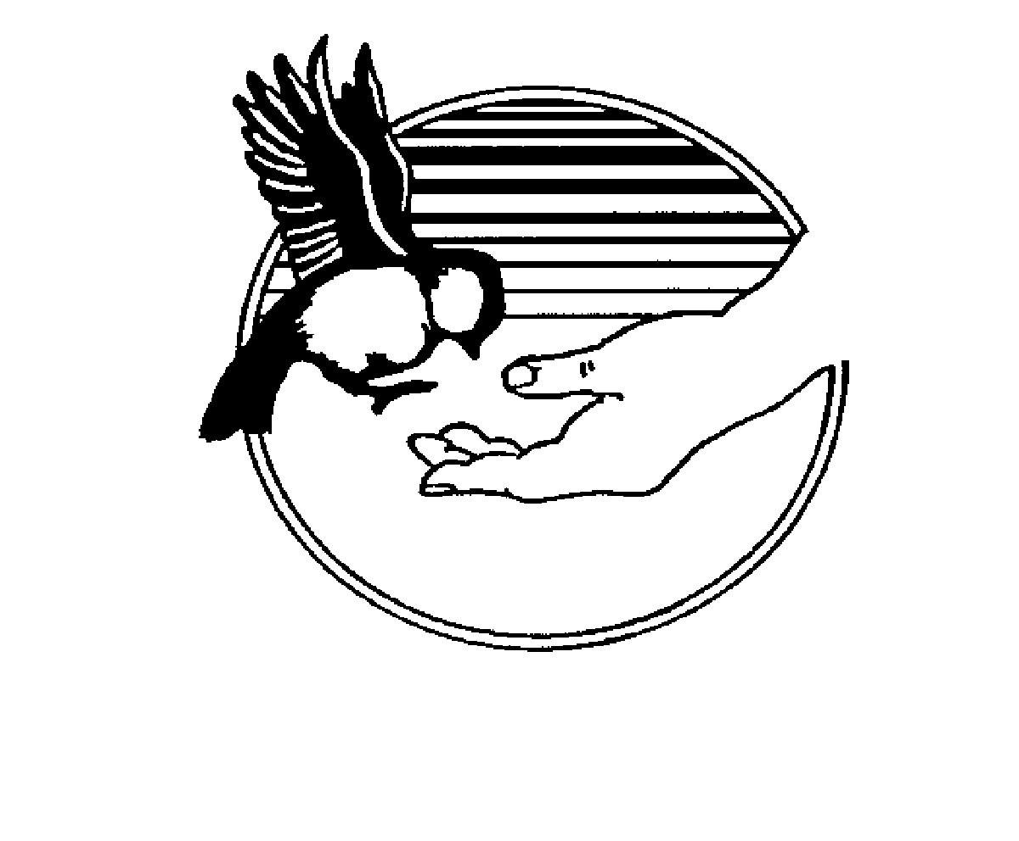****Groundwater: Explore, Understand and Protect**

**Wrigley Corners  
Outdoor and Environmental   
Education Centre**

**Groundwater Geochemistry Remediation Group**

**Program Summary**

***Who are we?***

Three groups whose passion involves Earth Sciences and education.

1. The Geochemistry, Groundwater and Remediation Group in the Earth & Environmental Sciences Department at the University of Waterloo (UW).
2. The Earth Sciences Museum at UW.
3. Outdoor and Environmental Education (OEE) with the Waterloo Regional District School Board.

***What have we done?***

Created a program to help teachers educate students about how earth science is currently being practiced locally both in the field and laboratory.

The program is a blend of field and laboratory work, with packaged pre/post trip documents, all tied directly to the curriculum, specifically SES 4UI but can be applied to other courses (See below for specifics).

***How does the program work?***

There are 3 optional components to the program:

1. Pre-trip class activities
2. The field trip
3. Post-trip class activities

Each component can be completed separately, but to get the most out of the program we recommend the complete package.

***Program Details***

*Field component includes:*

1. A seepage meter test and stream study where the students will use the scientific method to learn about Earth processes and water flow through Earth materials. Field trip can be located at either Laurel Creek, on the North part of Waterloo or Blair Creek in the South.

*Lab/Museum component includes:*

1. Observing, touching and describing a soil core that was extracted in Waterloo. Students will see and feel the difference between various earth materials and get the sense of how intricate Earth history can be.
2. Students will observe and interact with a cross-sectional representation of our local geology. This cross section contains a variety of earth substrates and includes human elements like wells or leaky storage tanks. Students can observe what happens to groundwater flow through various materials and how humans can make decisions to reduce water consumption and protect water sources.

Pre/Post trip material includes:

1. Porosity lab
2. Permeability lab
3. Grand River Geoscape activities

Premade class kits are available for loan to interested teachers and include:

* Glacier and post-glacier model
* 20 Stereograms and 10 stereoscopes
* 1 Gallon bucket of till
* 5 Sieves
* 5 – 1 liter bottles
* 5 – funnels with stopper spouts
* 5 – graduated cylinders
* 1 Stop watch

***Other Program Details***

* The program and program materials are free
* UW Earth Science Lab tours are available upon request
* Busing is free (for at least the OEE part of the trip and financial support currently available for UW part as well, though schools will have to apply for this cost to be covered separately).
* Can be adjusted to individual classes needs, and the advanced High Skills Major program.

***How to book a tour?***

1. Teachers can sign up to attend the program through the annual Outdoor Education booking process in June (same as other field trips). Watch for the OEE bookings system memo.
2. Class Kits can be borrowed from the Earth Sciences Museum or OEE centers. Kits will be delivered to the school.
3. Program and class activity downloads are free from the websites provided below.

***For more information visit or call:***

Outdoor Ed Guys

Levi Moore – 519 632 7503

<http://outdooredguys.wordpress.com/>

Earth Sciences Museum

Corina McDonald – 519 888 4567 x35633

<https://uwaterloo.ca/earth-sciences-museum/>

Geochemistry Groundwater Remediation

Susan Callan – 519 888 4567

<https://uwaterloo.ca/groundwater-geochemistry-remediation/>

**Groundwater: Explore, Understand and Protect  
SES 4UI Curriculum Connections**

|  |  |  |
| --- | --- | --- |
| **Program Outline** |  | **2008 Revised SES 4UI Curriculum** |
| **Pre-trip / In class** | | |
| *Glaciation*   * Aerial photos * Model study |  | *Fundamental Concepts -* Geological Processes   * Systems and Interactions   *Fundamental Concepts –* Earth Materials   * Structure and Function * Sustainability and Stewardship   *D. Recording Earth’s Geological History*   * D2.2 * D3.1   *F. Geological Processes*   * F2.1 * F2.8 * F3.5 |
| *Water cycle review and focus on groundwater recharge, discharge* |  | *Fundamental Concepts -* Geological Processes   * Systems and Interactions |
| *Porosity and Permeability Lab*   * Glacial till and the makeup of moraines |  | *A. Scientific Investigation Skills and Career Exploration*   * A1.1 – A1.13 Initiating, Planning, Performing, Recording, Analysing, and Communicating * A2.1 Geochemist, Hydrologist and Hydrogeologist   *E. Earth Materials*   * E1.1 * E2.1 * E2.2 * E2.7 * E3.5   *F. Geological Processes*   * F2.1 * F2.8 * F3.5 |
| **Field Trip** | | |
| *Bus trip to Laurel Creek or Blair Nature Centre*   * Land use in Waterloo Region * Seepage meter Activity * Stream flow and Discharge Activity |  | *Fundamental Concepts -* Earth Materials   * Structure and Function * Sustainability and Stewardship   *A. Scientific Investigation Skills and Career Exploration*   * A1.1 – A1.13 Initiating, Planning, Performing, Recording, Analysing, and Communicating   *F. Geological Processes*   * F2.1 * F2.8 * F3.5 |
| **Program Outline** |  | **2008 Revised SES 4UI Curriculum** |
| *University of Waterloo (Museum)*   * Drill core study   Groundwater Model Activity |  | *A. Scientific Investigation Skills and Career Exploration*   * A2.1 Driller, Geochemist, Hydrologist and Hydrogeololgist   *E. Earth Materials*   * E1.1 * E2.1 * E2.2 * E2.7 * E3.5   *F. Geological Processes*   * F2.1 * F2.8   F3.5 |
| **Post-trip / In class** | | |
| *Grand River Geoscape Poster Study* |  | *D. Recording Earth’s Geological History*   * D2.2 * D3.1   *E. Earth Materials*   * E1.1 * E2.1 * E2.2 * E2.7 * E3.5   *F. Geological Processes*   * F2.1 * F2.8   F3.5 |