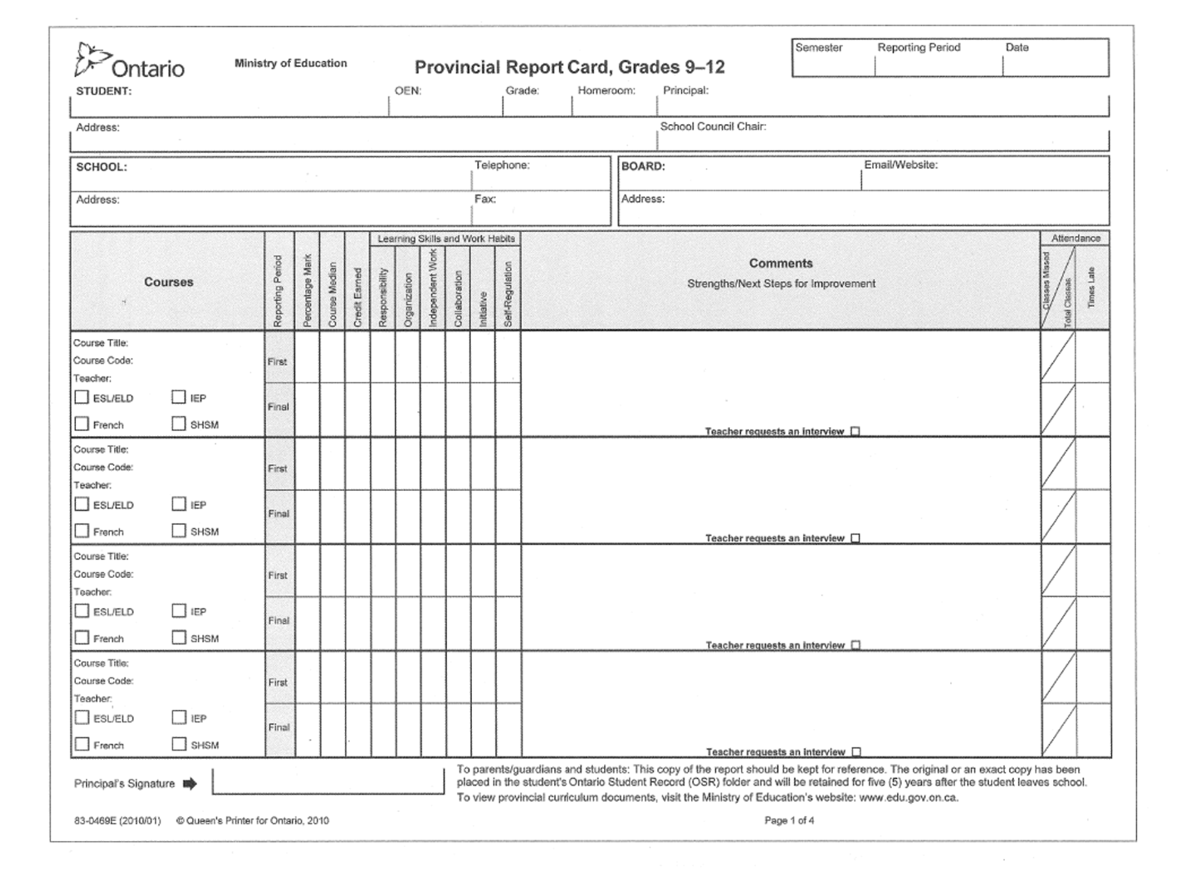

Information about individual course absences and the number of times your child has been late for class is reported here.

An “I” in place of a mark (Grades 9 and 10 only) is an indicator that key demonstrations of learning are missing or incomplete. On the final report card, an “I” indicates that no credit is granted.

The percentage grade for each course is shown in this column. The percentage grade reflects your child’s most consistent level of achievement, and is determined on the basis of both mathematical calculations and teachers’ professional judgement and interpretation of the evidence of learning. From the first report card to the final report card, this percentage grade may change, as your child continues to work toward providing evidence of essential learning for each course.

Achievement below 50% will be shown differently depending on the grade of the course. For Grades 9 and 10, you may see an “I” or 45; for Grades 11 and 12, you may see a number between 35 and 45. These are the minimum percentage grades used to represent any achievement below Level 1, and are not necessarily an indication of achievement that is “close” to a pass.

Pay close attention to the comments that the teachers have written in these spaces. The teachers’ comments for the various courses will be an indicator of:

• Your child’s learning in each course

• Strengths that your child has demonstrated

• Areas of improvement, including Learning Skills and Work Habits

• Whether there is missing evidence of learning

• Next steps for your child

The Learning Skills and Work Habits area is one of the most important indicators of how your child is learning. The development of the 6 Learning Skills and Work Habits is indicated by E, G, S or N.

In November, you will receive the first Provincial Report Card for the semester which will provide information regarding your child’s development of Learning Skills and Work Habits, total number of absences and lates, and final percentage grades.