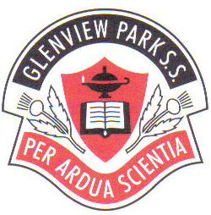
GLENVIEW PARK SECONDARY SCHOOL
COURSE SELECTION SHEET
2020 – 2021

Student Name:

HomeroomTeacher:

This Year’s Courses Next Year’s Courses
(Name) (Code) (Name) (Code)
Eg | Example  ENGLISH | ENG 3CI | Eg | Example  ENGLISH | ENG 4CI
1 |  |  | 1
2 |  |  | 2
3 |  |  | 3
4 |  |  | 4
5 |  |  | 5
6 |  |  | 6
7 |  |  | 7
8 |  |  | 8
9 |  |  | 9
 | ALTERNATIVE CHOICES (if a class is cancelled, these are my next choices)
1. |  |  | 2.
Semester 1 only (ZEM 1WN) Co-op COPFAS Not Returning Working
Semester 2 only (ZEM 2WN) COPGEN College
Learning Assistance LEA 0AS (LAC) COPTEC University
Learning Assistance LEA YAS (LAC) Military Co-op Unknown
Alternative
School
SHSM Arts & Culture (SHSMAR) Other Dual Credits (Course)
Environment (SHSMEN) Summer School (Course)
Health & Wellness (SHSMHW) Night School (Course)
Information & Communication(SHSMIT) eLearning (Course)
Transportation (SHSMTR)

Student Signature: Date:

Parent Signature: Date:

