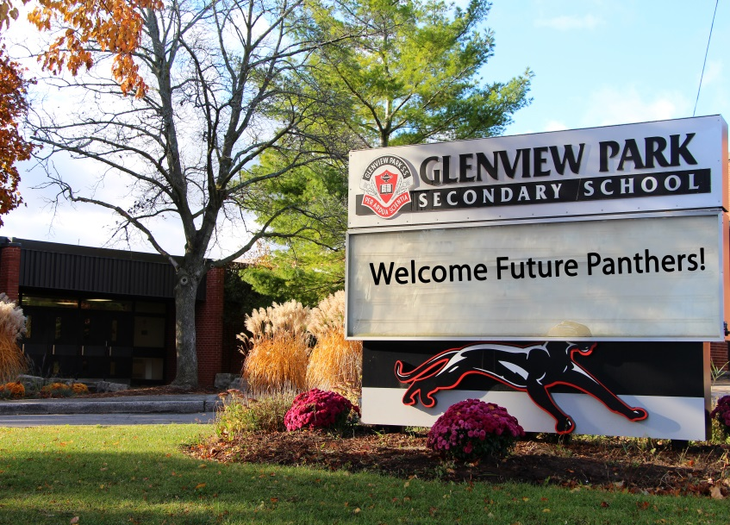

**An Invitation to**

**Glenview Park Secondary School**

**Grade 8 Information Night**

*Information Session starts a 7:00pm, followed by Guided Tours.*

**For more information contact:**Vanda Martins-Gardiner, Guidance Dept. Head

Email: vanda_martins-gardiner@wrdsb.ca   
Phone: (519) 621-9510 ext: 5525

http://gps.wrdsb.ca

**Learn about:**

* *Application Process*
* *Fast Forward Program*
* *Grade 9 Course Selections*
* *IB Preparation Program (grades 9 & 10)*
* *Levels of Course Study*

**Wednesday  
January 15, 2020**

**7:00 – 9:00 p.m.**

55 McKay Street, Cambridge, Ontario N1R 4G6