12 Days of Giving
Grand View School wants to make it a
Merry Christmas for our community.
We are joining the
Cambridge Firefighters 2019 Basket Fund
by collecting new unwrapped items from December 2 – December 17
Each day staff and students are asked to bring in a different item to go under the
Christmas Tree in the Library.

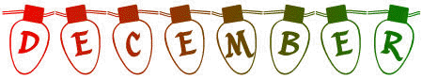
Monday | Tuesday | Wednesday | Thursday | Friday
2  A Toothbrush and Toothpaste | 3  A Stuffed Animal | 4  A Pair of socks  (Adult & Child) | 5  A Fun Board Game | 6  Pasta and Sauce
9  A Really Good Book | 10  Any Kind of Canned Food | 11  A Brand New Toy | 12  Warm Pyjamas  Slippers  (Adult & Child) | 13  Colouring Book and Crayons
16  Toiletries and Diapers | 17  Mitts, Hat & Scarf  (Adult and Child) | 18  Items will be  picked up | 19 | 20
Cambridge Firefighters will be picking up all donations on December 18th.
Please participate as you are able.

