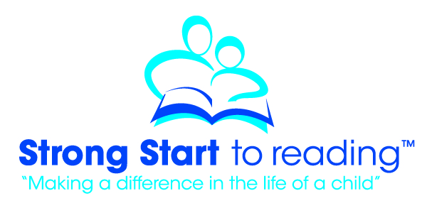
Strong Start to Reading – Some Basic Information for Volunteers
What is Strong Start?
Strong Start is a registered Canadian children’s charity that works in partnership with schools and school boards across Ontario to offer an early literacy intervention program called Letters, Sounds and WordsTM for young children in elementary schools. The program is organized into 4 strands: Letters, Sounds, Words, and Building Words. The children are enrolled in two or three of the program strands at the same time.
The Strong Start Letters, Sounds and Words program is offered to children in senior kindergarten, grade one and two who need a literacy boost. Volunteer Reading Coaches use carefully designed games and activities to help a young child learn the names of letters, sounds, or sight words. Volunteer coach manuals provide step by step instructions for each session. The program is offered during the school day over a 10 week period. Children work with a trained volunteer for 30 minutes, 2 – 3 times each week for 10 weeks (usually a different volunteer for each strand). All of the materials needed to implement the program are provided by Strong Start.
How much time to I need to become a volunteer?
If you have at least 30 minutes per week for 10 weeks, and have an interest in helping a young child learn to read, you can become a Volunteer Reading Coach with the Letters, Sounds and Words program. If you have more time to give, you may be able to work with more than one child.
How are volunteers trained?
Part 1 and part 2 training sessions (two, 2-hour sessions for a total of 4 hours) are offered to volunteers to become a certified Volunteer Reading Coach. The training is offered free of charge. Certified trainers deliver the training in various schools around the region. Register here for training.
How do volunteers benefit?
All volunteers who complete the training and the 10 weeks of the program with a child are awarded a certificate and a gift from Strong Start. Volunteer Reading Coaches gain valuable experience in working with young children and the training is a great addition to a resume. Seeing the growth in skills and confidence in a young child is truly rewarding. The experience of being a Volunteer Reading Coach enables volunteers to give back to their community in tangible ways. Volunteers see the positive impact of their gift of time first hand.
How are volunteers placed after the training?
Following training, volunteers are matched with a school according to their preferences. Almost all elementary schools in WRDSB and WCDSB run a Strong Start program and are in need additional Volunteer Reading Coaches to support children in their school.

For more information contact your child’s school or visit our website at www.strongstart.ca

