KEATSWAY Public School
Winter Update 2019

Hello Keatsway Families,

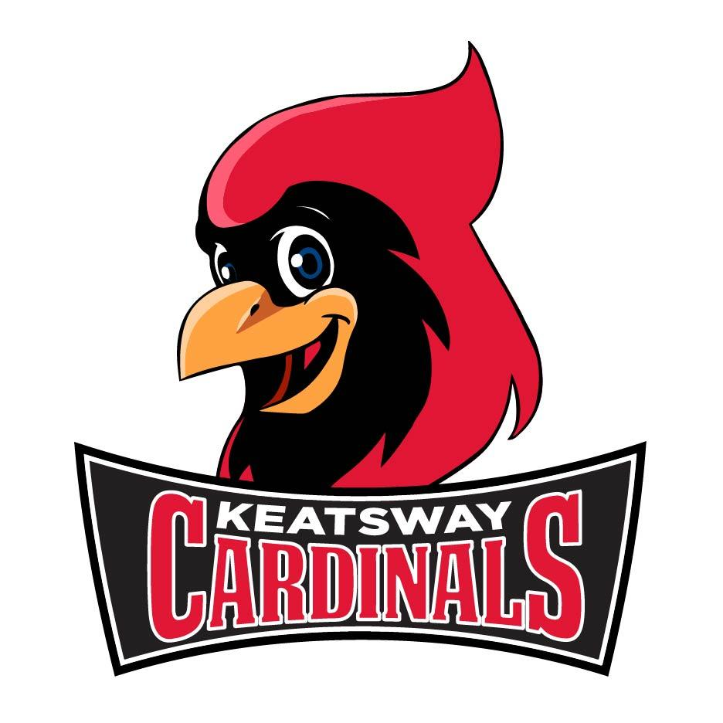
We have had a fantastic start to the 2019 year! We trust that everyone had a wonderful holiday season. We sure had a lot of snow and extreme cold weather over the last few days. When I go outside and look out at the fields it makes me happy to see all the children having fun and playing in the snow. They are building snowman, forts and snow angels! Please remind your children to be safe at all times with the snow. Remind them that is it not safe to play on snow banks that are close to parking lots or roads and that we don’t throw snowballs at school. We want everyone safe and happy this winter season. Please send your children bundled up with snow pants, hats and mitts. We look forward to many exciting activities and events in 2018 and hope to see you there!

We have a new Mascot - check out our new CARDS!
With our new Mascot, we have decided to offer Spirit and Athletic Wear.
Please go to this link to view our Spirit Wear:
https://northland.gearware.com/Shop/Store.aspx?sid=5

A few notes for our Parents/Guardian:

The parking lot is not to be used for walking children through or parking in at bell times. PLEASE use the path and sidewalks!

Please write in your child’s planner if your child is getting picked up early - it makes our jobs so much easier.

Term 1 Report Cards will be coming home on Friday February 15th. If you would like to discuss the Report Card with your child’s teacher, please call to setup an appointment or telephone call.

Winter Carnival will be on Friday, February 15th. Grades 1-6 students will spend the afternoon participating in many different activities while celebrating the French-Canadian Culture of Carnaval d’Hiver!

Kindergarten Registration is currently underway for all students born in 2015. Please go online to www.wrdsb.ca to register your child.

March Break begins on Monday March 11th through to Friday March 15th.

KEATSWAY FREE THE CHILDREN STUDENTS is having a Food Drive on FEBRUARY 1 - MARCH 8, this local initiative will support our own community. Thank you for your donations!

Keatsway Spirit Days for the 2018/19 year

February 14th - Red/White/Pink Day March 8th - Jersey Day
April 11th - Crazy Sock Day May 24th - Twin Day
June 27th - Red/Black/White Day

Pizza Days will be every Monday. When a Monday is a holiday, Pizza Day will be on the Tuesday. Pizza slices are $2.00 each with options of pepperoni, cheese or veggie. Please send exact change with your child.

School Council News:
What a great first half of the school year we have had and we ended the year with three super events! Thank you to all who attended, supported and volunteered at the Winter Marketplace — it was a great success! It was also fantastic to see so many families and staff dining together at Boston Pizza before the holidays. And lastly, we celebrated one of the kids’ favourite days - Cookie Day!

Upcoming Dates and Information to Remember!

Albert Einstein once said: “I have no special talent. I am only passionately curious.” Keatsway’s annual Science Fair is an opportunity for students to follow their own curiosity, explore a topic of interest, and to share their knowledge with the Keatsway community. Students in any grade are invited to participate in this voluntary, non-competitive event that will take place on Wednesday, February 27. Please bring $4 and a registration form to the school's front lobby before or after school on February 15, 20 and 21 to register and pick up your display board. For more information or to volunteer, contact parent volunteers Rebecca Steinmann and Jennifer Lhotak at keatsway-science-fair@googlegroups.com

School Council Meetings

Our next School Council meeting is on Thursday February 21st. Our April date has been changed to Thursday, April 11th and the last meeting date for this school year will be Thursday, May 16th. Meetings are held in the library from 6:30-8:00 and free babysitting is provided. We hope to see you there!

There is still time to join in on School Council. Involvement need not be a major time commitment and can occur at any time throughout the school year. It might mean attending some or all of the meetings, helping out with a fundraising event, joining a committee, or simply reviewing the meeting agendas and minutes and providing some feedback where appropriate. It can be done during or after school hours, or from home. If you wish to receive a copy of the Meeting Minutes, please contact us at keatswayschoolcouncil@gmail.com to be put on the email list. You can also keep advised of what is going on at the school through our Facebook page - https://www.facebook.com/keatswaypublicschool/ (Keatsway Public School Parents).

WHY GET INVOLVED IN KEATSWAY’S SCHOOL COUNCIL?
- Research has shown that parental involvement in their children’s school is a major factor in the children achieving their best. Involvement in the School Council is a way to show your son or daughter how much you value his or her school and education.

- The school principal and teacher representative report at every meeting on activities and programs at Keatsway and in the school system – this is a great way for you to keep informed as a parent.

- Parents have the opportunity through the School Council to influence decisions made by the administration at Keatsway, the School Board and the Ministry of Education.

- Meetings are informal, with free babysitting, and it’s a great way to get to know other parents.

- Through its fundraisers, School Council pays for important materials and activities at Keatsway. Without the work of parent volunteers, many students would miss out.

FUTURE EVENTS
Pasta Night will be Thursday, April 18th!

This is an evening where Keatsway families can come together as a community and share a meal in the gym. Details to follow.

And our last event for the year will be… Thursday, June 20th!

In our Community…..
A new community centre has recently opened in the Erb West neighbourhood! Carizon is working in collaboration with the Region of Waterloo to provide community space for neighbours to meet, create new meaningful opportunities, connect to services/resources, and to celebrate together! We believe that the neighbours of Erb West have many assets and gifts to offer one another to create a stronger and more vibrant community, and it is our goal to help make these connections. We celebrated our grand opening on October 27th 2018, and now the space is open Monday-Thursday from 12:30-5:30pm. There are a variety of opportunities such as homework support for elementary students, a women’s social group, a food cupboard, activities for youth, an ESL class, and more!
Many local neighbours, and folks from outside the neighbourhood, have generously donated their time to some of the programs that are taking place in this community. Currently, we have some needs for volunteers who want to work in a “host” capacity greeting folks as they come to visit the centre. We will have a fresh food distribution program starting soon and that will also require a lot of volunteer support. Everyone is welcome to stop by any time for a visit and to check out this new space. If you’d like to get in touch, you can contact us through the Erb West Community Centre Page on Facebook, or email jspunar@carizon.ca, or call 519-497-8254.

Wishing all of our Keatsway families a wonderful winter - stay warm and be safe!

Penny Miller Devrim Sherifali
Principal Vice-Principal

