Parent Presentation

Plus: FREE Movie Night for kids!
Raising Resilient Children
by Sherry Campbell M.A. RSW OACCPP (R)

What: A presentation for parents and grandparents that demonstrate principles of living and encourage a healthy, resilient and meaningful life. This presentation is of interest to parents who wish to promote a solid foundation of healthy living, and prepare their children for the inevitable challenges and struggles they will face in their futures.

- Overcome Failure
- Deal with Disappointment
- Cultivate a Healthy Self Image
- Deal with Struggles of Life
- Become Assertive rather than Aggressive
- Examine their Choices
- Delay Gratification
- Contribute to Others
Why: Too often parents buffer their children from the reasonable and natural consequences of their own actions. Parents that overprotect or rescue their children rob them of the opportunity to develop a track record of success in dealing with the pitfalls of life. This often leaves a child without the self-worth and problem solving skills necessary to function in society. This presentation encourages children to respond to life by choice rather than react to life by chance.
January 28th, 2014 at 6:30pm
Where: Lincoln Heights Public School
Cost: FREE – brought to you by Lincoln Heights Parent Council


ENJOY THE PRESENTATION – WHILE YOUR KIDS ENJOY A MOVIE!
To keep your kids occupied during the presentation, we will be hosting a
FREE movie night for the kids

Please fill in and return to the school

- Yes, I would like to drop off my ___ child(ren) for a movie while I am at the parent presentation
- Yes, I would like to go to the parent presentation. No children supervision required

(Note: there will be adult supervision - children must be school age and parents must stay on school property)
About Sherry Campbell
Sherry Campbell M.A. RSW OACCPP (R)Psychotherapist
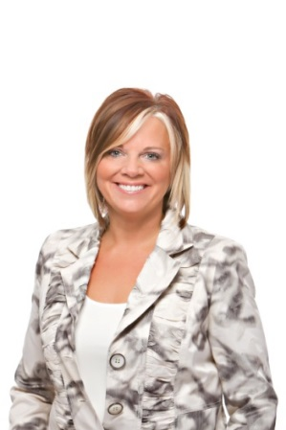
Sherry is a professional speaker as well as the principal psychotherapist and owner of Sherry Campbell Counselling Group. She is a registered Psychotherapist with the Ontario College of Social Workers and Registered Social Service Workers (RSW), and also with the Ontario Association of Consultants, Counsellors, Psychometrists and Psychotherapists (OACCPP).

Sherry earned her Master’s Degree in Life Span Developmental Psychology and has extensive training and experience in trauma, marital, individual, group counselling as well as personal growth. Sherry also holds her certification in Critical Incident Stress Debriefing, providing immediate onsite assistance to organizations in need.

Sherry’s clinical experience includes almost 20 years as a psychotherapist with children, teens and adults. Sherry has worked as the sexual abuse, trauma and domestic violence psychotherapist in the Niagara Health System.

Recognized as the Greater Niagara Chamber of Commerce Outstanding New Business of 2011and Women In Business Entrepreneur of the Year 2012 and most recently received the 2013 Business Excellence Award from the Greater Fort Erie Chamber of Commerce.
As a psychotherapist, counsellor and Coach, Sherry provides all clients with professional, confidential, non-judgmental and ethical service.

For more information visit www.SherryCampbellGroup.com

For every problem there is a solution!

