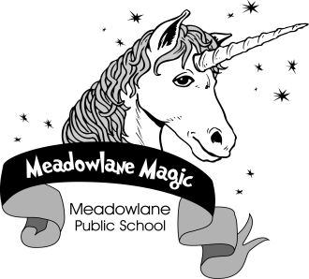

Meadowlane Public School
236 Forestwood Drive, Kitchener, Ontario N2N 1C1
Tel: (519) 579-5030 Fax. (519) 579-2851

Costume Day at Meadowlane – Tuesday, October 31st

We are going to be holding a “Costume Day” on Tuesday, October 31st. Students are encouraged to dress up as their favourite story book character, super hero, sports hero, occupation, or any other costume that they have at home or can easily create. Students can also choose to wear black and orange. Please keep in mind that costumes should not be disrespectful of others. If something is representative of a person’s culture or religious beliefs, then it should not be worn as another person's costume. For safety reasons, we do not allow the wearing of masks and the carrying of plastic weapons. Weapons, real or fake, are not to be brought to school on any day, so Halloween is not an exception.
Kindergarten students are permitted to wear their costumes first thing in the morning. Please make sure that your child has their regular clothes under their costume. If that is not possible, they will need a change of clothes that they can change easily into at first nutrition break. Students in Gr. 1-6 will change into their costumes for the last block of the day. More information will come home from your child’s teacher about the specifics of their class celebration.

On Halloween, and everyday, we continue to create an environment where every child feels included, valued and treated with dignity.

If you have any questions or concerns, please contact your child’s teacher.

R. Jutzi
Principal

