WORLD WAR ONE
Preston Soldier Research Assignment

Taking your soldier names from the cenotaph, and the names of the two battles, begin your research into the Preston community’s involvement in the First World War.

Soldier Research – Stage One

- Go on the internet to Library and Archives Canada (http://www.bac-lac.gc.ca/eng/discover/military-heritage/first-world-war/first-world-war-1914-1918-cef/Pages/search.aspx)
- In the search boxes, type in the name of the soldier you are looking for.
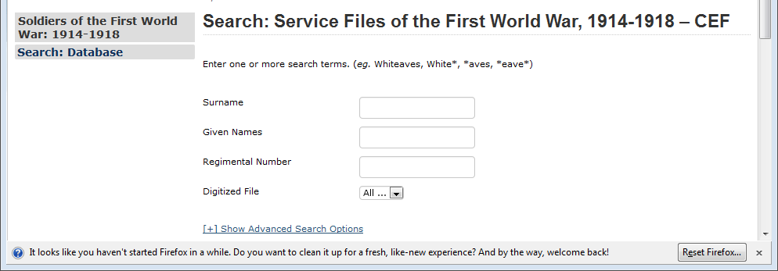
- Depending on the last name, several names may appear.
- Click on the name closest to the one you are searching for, and you will see a digital copy of the man’s attestation papers. Click on it to enlarge.
- Look for Question 2 “In what town, township or parish and in what country were you born?” It should say Preston. That will be a good clue that this is the right man for you. Then, print both pages (front and back).
- Rinse and repeat until you have at least 3 sets of attestation papers.

Soldier Research – Stage Two

- Taking the names of the soldiers you found in stage one, go to the Canadian Virtual War Memorial (http://www.veterans.gc.ca/eng/remembrance/memorials/canadian-virtual-war-memorial)
- In the search box, type in the name of your soldier. Sometimes, if you use first and last, you will not get the result you need so vary your search parameters.
- Hopefully, if you get a hit, you will see extra information on your soldier, including photographs, perhaps an obituary…anything can appear here! It should also include his death date and burial information; make sure to record these.
- Print off all of these that you find useful to use as part of your poster presentation as well.
- Rinse and repeat for your other soldiers.
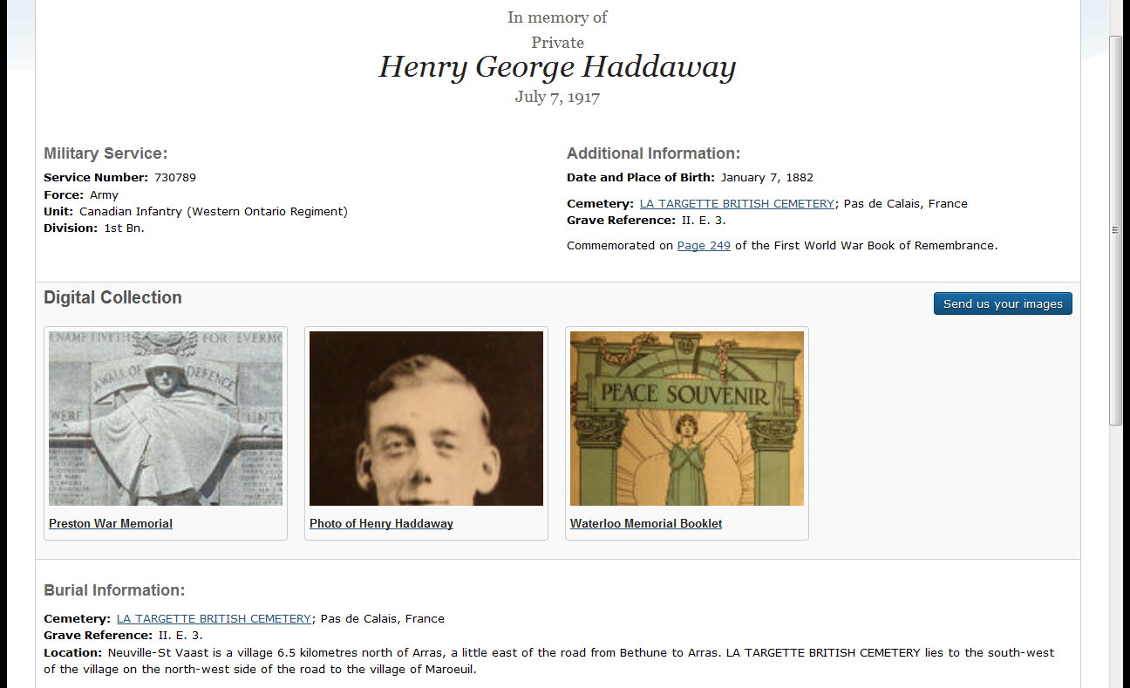

Soldier Research – Stage Three
1. Taking the names of the two battles you took from the cenotaph, research them using any one of a number of good websites on Canadian battles (NOT Wikipedia). Some of these include:
- First World War.com: The War to End All Wars (http://www.firstworldwar.com/)
- War Diaries of the First World War (National Archives of Canada) (http://www.bac-lac.gc.ca/eng/discover/military-heritage/first-world-war/Pages/war-diaries.aspx)
- Canadian War Museum (http://www.warmuseum.ca/home/)
2. In a well-written paragraph, outline the major details of the battle, and in particular Canada’s role in it during the First World War. You should have two well structured paragraphs when you are finished.
3. Now find and collage AT LEASE 10 images that relate to the lives of soldiers from Canada in the First World War. You can find these at many sites; try FirstWorldWar.com or type “First World War Canada” under Google images.
6. Glue the attestation papers on the Bristol board supplied. Now collage the images “over the top” and put the battle information in the middle.
EVALUATION:
To get a Level … | You must complete…
1 (50-65%) | - 1 attestation paper  - 1 burial information (for same or different)  - 1 Remembrance image  - 10 pictures  - Attached to Bristol Board
2 (65-79%) | - 2 attestation papers  - 2 burial information (for same or different)  - 2 Remembrance image  - Basic paragraph (main points, no real creative effort)  - 10 pictures (some in colour or coloured by you)  - Attached to Bristol Board
3 (80-89%) | - 3 attestation papers  - 3 burial information (for same or different)  - 3 Remembrance images  - Well-writted paragraph (main points, some creative effort, clear connection to what we are learning in class)  - 12-15 pictures (some in colour or coloured by you)  - Attached to Bristol Board
4 (90-100%) | - 3 + attestation papers  - 3 + burial information (for same or different)  - 3 + Remembrance images  - Well-writted paragraph (main points, some creative effort, clear connection to what we are learning in class)  - 15+ pictures (some in colour or coloured by you)  - Attached to Bristol Board

