Pioneer Park – NUTRITION FOR LEARNING
COOKIE DOUGH SALE!
We need your support! We are participating in a cookie dough fundraiser to help fund our
Nutrition for Learning!
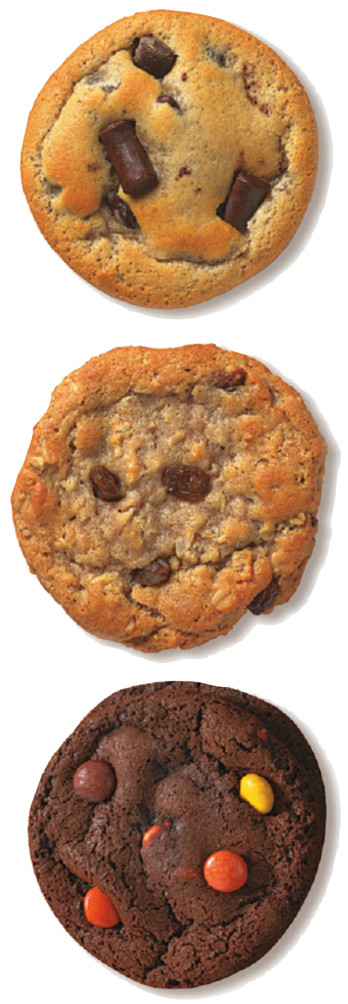
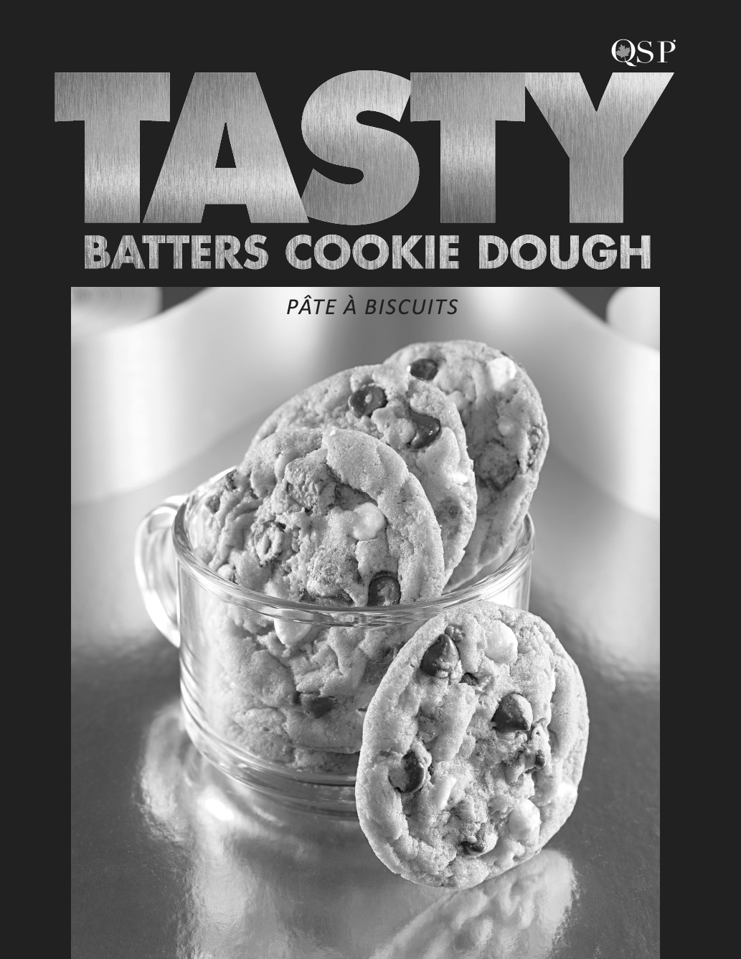
Tasty Batters Delicious Gourmet Cookie Dough & Mini Loaves are made in Concord! Both are trans-fat free and stay fresh 6 months in the freezer.
Help students sell items from the enclosed catalogue. We will earn 30-40% profit per frozen unit sold dependent on total volume sold. Take students to visit friends, relatives and neighbours.
Ask co-workers to purchase too. Students have been advised against door to door sales.
Extra order forms are available in the office.
MARK THESE DATES ON YOUR CALENDAR!
ORDERS AND PAYMENT ARE DUE
MON, FEB 13, 2017
(CHEQUES ARE PAYABLE TO OUR SCHOOL)

THE COOKIE DOUGH WILL BE DELIVERED:
TUES, MARCH 7, 2017

COOKIE DOUGH IS FROZEN AND MUST BE PICKED UP THIS DAY.
Two ways to order / sell cookie dough:
1) Shop online at www.QSP.ca with our
ONLINE ID: 4697157
2) Use the LARGE ORDER FORM. Keep the pink copy for your records.
Payment is required by cash or cheque to our school.

