

__Queen Elizabeth Public School _ has a *free* parent workshop coming up!

Back to School 101- Getting back into the routine

When: Thursday September 29th from 9am-10:30am

Where: Queen Elizabeth

Who: Any parent who has a child attending Queen Elizabeth

*Coffee and treats will be provided*

Anyone who is interested in attending please call Jamie Keyzer at 519-741-1122 ext. _226___. Just leave a message indicating how many people will be attending with you.

**Carizon Family and Community Services Coffee and Conversation Parent Workshop**

Want to connect with other parents, learn different parenting strategies, and discover community resources?

If yes, then join us at Queen Elizabeth School for a parent workshop run by a Carizon Community Resource Worker.

**For more information, please contact:**

_____Jamie Keyzer _______

_____jkeyzer@carizon.ca

519-741-1122 ext. ­­­­226____

**Head office: 400 Queen Street South, Kitchener, ON N2G 1W7 519-743-6333 info@carizon.ca**

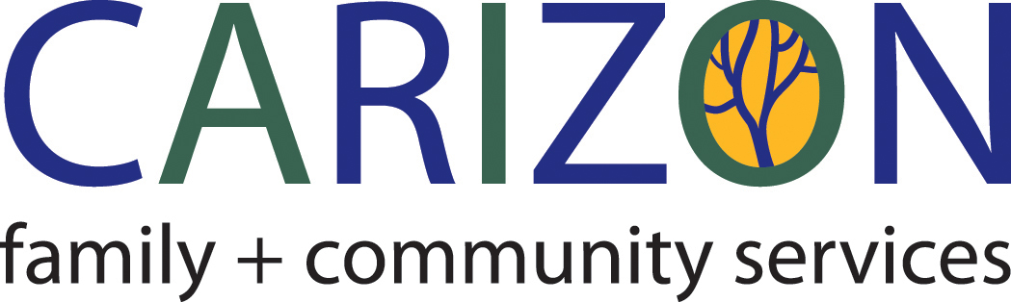

**www.carizon.ca**