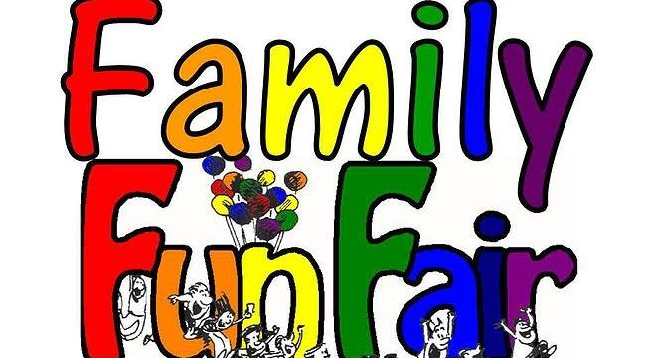
Sandhills Public School
Tuesday June 12th, 2018
5:30 – 8:30p.m.

Petting Zoo Face Painting
Rides Ice Cream
Games BBQ
Raffel
Sweet Temptations Food Truck (Gourmet Cupcakes)
Ticket Prices:
15 tickets for $20.00
30 tickets for $30.00
Come on out to our Fun Fair fundraiser and enjoy an evening out with the family while also supporting our school’s fundraising efforts!

