Terra Cotta Cookie Co.
Nutritional Information

CHOCOLATE CHIP DELITE
Ingredients: Enriched wheat flour, brown sugar, sugar, semi-sweet chocolate chips (sugar, unsweetened chocolate, cocoa butter, anhydrous dextrose, soya lecithin, vanilla extract), liquid whole egg, soybean and palm oil margarine, unsweetened applesauce, inulin, vanilla extract, baking soda.
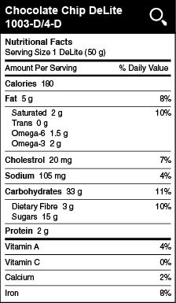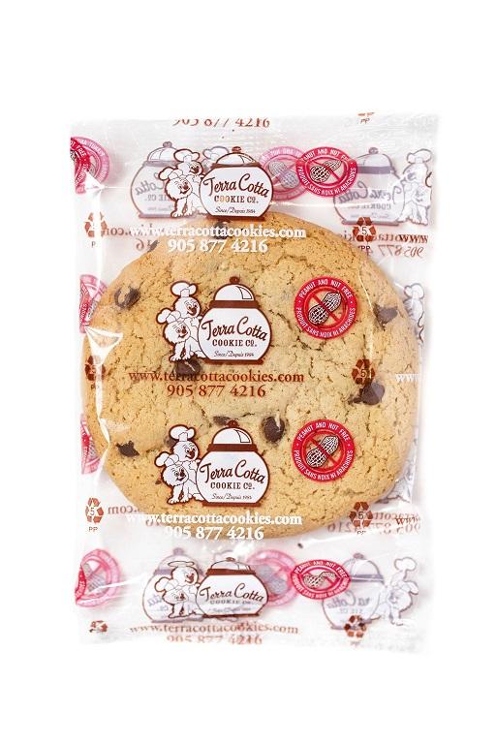

WHITE CHOCOLATE FUDGE DELITE
Ingredients: Enriched wheat flour, brown sugar, sugar, liquid whole egg, soybean and palm oil margarine, white chocolate chips (sugar, cocoa butter, whole milk powder, skim milk
powder, butteroil (milk), soy lecithin, vanilla extract), unsweetened applesauce, cocoa, inulin, baking soda.

