



184 Tait Street, Cambridge, ON N1S 3G3

Main Office (519) 621-7621

**Attendance Check (519) 570-8137 ext. 3846**

**Web: tai.wrdsb.ca Twitter: @TaitPS**

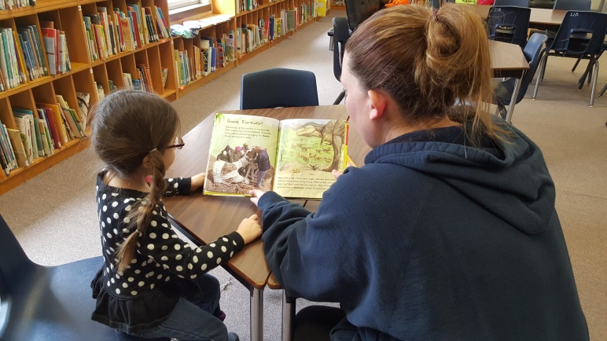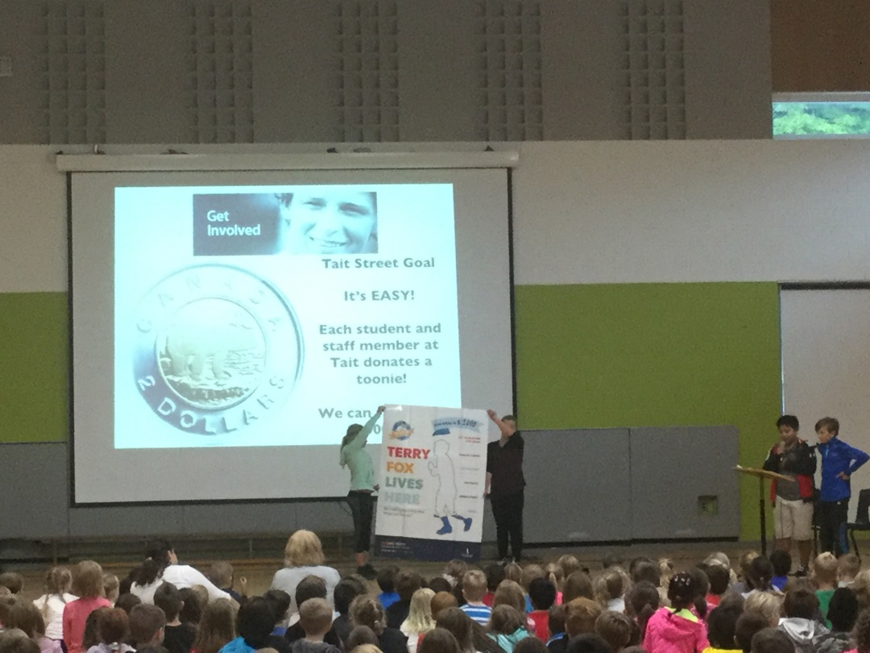

Administration Messages

We are well into October and many great activities have already occurred here at Tait including field trips to the Safety Village, Blair Outdoor Education Centre, and downtown Galt. Our staff continues to be excited as they work with their students and their families. We continue to embed the Eight Keys of Excellence along with a “Growth Mindset” into all we do to help our students achieve to the highest they can. Almost all of our activities and events can’t happen without the many volunteers who support Tait Street. Thank you to everyone involved in supporting our Tait Street community and making it great. We look forward to a great year at Tait!

Tait Administrators - James Bond 007 & Jenni Guy

Dates to Remember

|  |  |
| --- | --- |
| Dates | Activity or Event |
| Oct 27 | MacMillan’s Order Pick-up  3-6:30pm |
| Oct 28 | Photo retake – 9:10 am |
| Nov 6 | Daylight Saving Time Ends |
| Nov 11 | Remembrance Day |
| Nov 8 | School Council Meeting 7pm |
| Nov 17 | Tait Movie night – 6:30 |
| Nov 18 | PD Day – Interviews (PM) |
| Dec 15 | December Concert 2pm & 7pm |
| Dec 26 | Winter Break Starts |
| Jan 9 | Back to School |

School Picture Retake

**Friday, October 28 (am only)**

**Remember to return the original package if you require a retake.**



October 2016 Newsletter

From the Office

**Medication** If your child needs to take prescription medication at school please make sure to fill in a form at the office.

**Vacation** If you are going on vacation please ask the office for a form before you go.

**Colder Weather** Please encourage your child to come to school dressed for the weather as we head into colder fall weather.

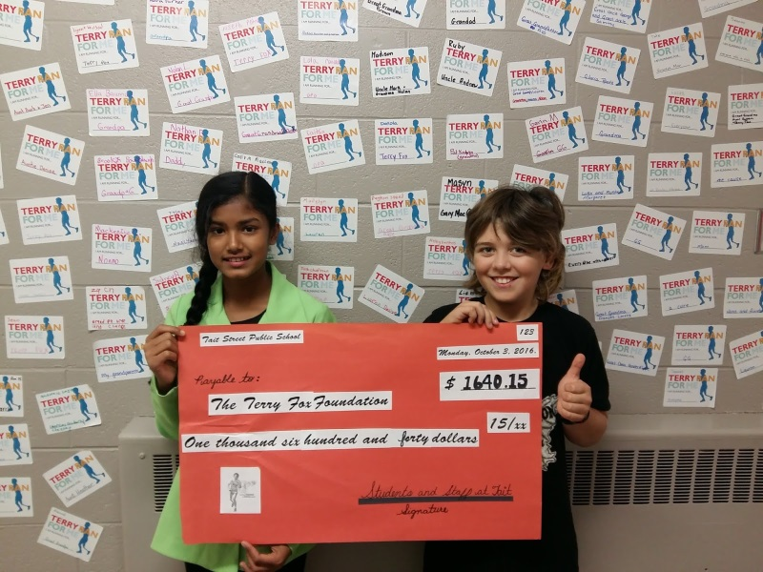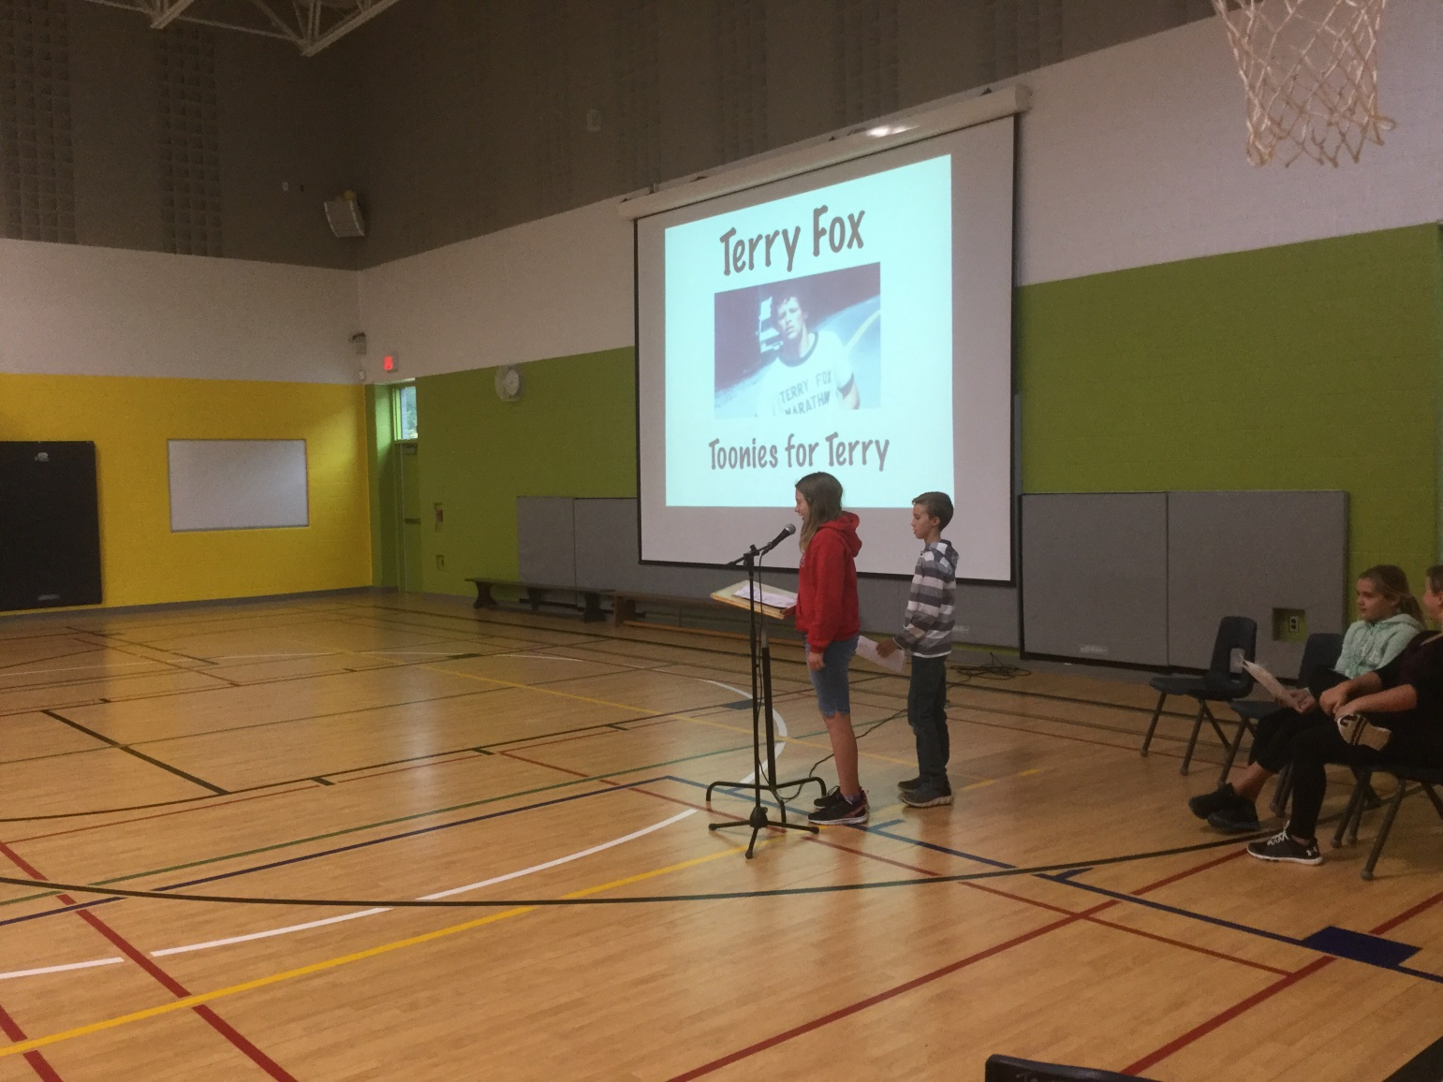

School Council

With the start of a new school year, the council is excited to welcome a number of new faces, as well as, returning members. Please continue to join us!

The following are your 2016-2017 School Council Executive: Mandi Ballentine (Chair), Jen Noble (Co-Chair), Bel Roth (Treasurer), and Tina Moore (Secretary).

# Fundraisers

The orders are in from our very successful MacMillan’s fundraiser. Once again, thank you for your help in raising money for our school. One project that will be supported from the proceeds of this fundraiser will be the purchase of Chromebooks for use in our classrooms.

Order pickup is: Thurs.Oct.27 between 3pm-6:30pm.

If you’ve found that your student’s items have been wandering, then maybe our ongoing ***Mabel’s Labels*** fundraiser is just what you need. With every order placed the school receives a percentage and we are that much closer to our fundraising goal! Please use campaigns.mabelslabels.com and choose Tait Street Public School (Cambridge) from the menu. Be sure to check out the exclusive fundraising combo!

# Food Days

Our special lunches have begun again, with pizza every Wednesday, and subs or pitas the first Friday of every month. Coming in November we will be introducing popcorn days! With lunches being so popular, we are excited to be exploring more options. If you have any suggestions, please let the office know.

All orders/payments will be collected during the last week of each month. Families with more than one student at Tait, are encouraged to pay for all pizza and sandwich orders together in one package. When paying this way, please send a package with one child that contains order forms for each child along with cash or a cheque to cover all of the orders together.

# Upcoming Events

We will be having a blitz beginning in November to kick off the launch of our ***Tait Street School Spirit Wear***! We all know Tait is great, and now we will be able to show it too!

Council was successful in applying for a PRO (Parents Reaching Out) grant and is busy planning an amazing ***Math night*** in the coming year.

Remember, we always enjoy seeing new faces!

Our next School Council meeting is **November 8th** at 7:00pm in the library.

# Volunteers

Our volunteer coordinator was excited to see the return of pink volunteer sheets! The information is being inputted and has already begun to be used. Remember, as a volunteer, you are an amazing resource. Please contact Shawna at [volunteertait@gmail.com](mailto:volunteertait@gmail.com) to pass along your details or for more information about opportunities around the school.

 Terry Fox Run

AMAZING!

We raised $1640.15 for cancer research!

On Monday, September 29th, all teachers and students from Grades K-6 took part in The Terry Fox Run in support of our Toonies for Terry fundraiser. Students went outside and got moving in a circuit around the school for forty minutes to raise money for cancer research. Not only was our goal of $1,000 reached but we surpassed it by $640.15! Thank you to Mrs. Whicher for organizing this event and to all the students and their families for making a donation and participating actively in Tait’s Toonies for Terry event. We kept Terry’s dream alive and his Marathon of Hope continues!

                                                                                                   By: Mackenzie K.