February 2, 2017

Dear Parents,
This morning the following incident was reported at Edna Staebler Public School. As it occurred in close proximity to Vista Hills, we wanted to make you aware of this.

Yesterday after school at approximately 3:15 two Grade 8 students were followed home by a man wearing dark clothes, a toque and a scarf covering most of his face. The man was on the opposite side of the road but crossed and started to follow them. He followed them home. This took place on Karlsfeld Road. The incident has been reported to the police.
We encourage students to walk home with a friend whenever possible. If your child sees anyone suspicious or anything that makes them feel unsafe, they must go to the nearest safe space and call 911.
Thank you for your support.
Paul Fracas
Principal

Thank you for your continued diligence in making plans for safe travels to and from school.
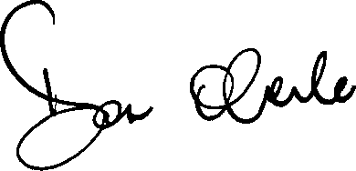
Don Oberle
Principal

