Vista Hills School Council Meeting Minutes

Date: Friday, November 19, 2021
Where: Google Meet, Invitation sent to interested participants
When: Thursday, November 18, 2021 at 6:30pm
Present: Amy Innes, Anne Plouffe, Bhaleka Persaud, Diana Clipsham, Greg James, Jennifer Christopher, Katelyn Brunskill, Melanie Roberts, Penny Miller, Raneem Al-Halimi, Sharon Han, Bryden Eby, Jennifer Huff, Jansi Mollin, Sara McEachern, Shawn Humes,

Meeting Agenda

1: Welcome and Approval of Minutes—Melanie Roberts
- Meeting minutes of October 21, 2021 approved: Melanie Roberts motioned and Anne Plouffe seconded; Motion Passed.

2: Vista Hills Updates – Penny Miller, Amy Innes
- Instructional Update – Penny
  - Report Cards – interim progress report went home this week
  - This Friday (tomorrow) is a PD Day. Kids are at home but teachers and staff are meeting and developing skills and strategies
  - Home Reading – school is missing a considerable number of books over the last few years and is seeking funds from school council to replenish supplies of books for home reading program.
    - Tabled request for end of meeting when School Council will consider all requests for funding
  - Music – Rotary music has begun for grade 7 and 8 students.
  - Strong Start Program kicking off. Check out https://www.strongstart.ca/ for ways to get involved at home and at school
- Activities Update - Amy
  - Extra-curricular sports and intramural sports and programs for Grade 7s and 8s are getting underway, and other grades activities will follow shortly.
  - Remembrance Day outdoor event was very successful. Great participation by students, teachers and parents.
  - We are evaluating inviting another guest speaker to come to the school and present to students, as well as parents (like what we did with Sara Westbrook last year). Requested funds ($500-$1000) from School Council to help fund.
    - Tabled request for end of meeting when School Council will consider all requests for funding

3: STSWR Update – Bryden Eby

- Bryden presented a Drive to 5 draft map of the area surrounding the school to share alternate transportation options with parents, specifically to encourage more walking. This map will be shared with parents in the coming weeks leading up to our Traffic Safety Blitz week.

4: Update of VH Traffic Safety Plan – Melanie Roberts
- On December 1, STSWR has planned a data collection day where they will be counting traffic behaviors at the school during drop off and pick up times. We will also have a representative from the City who will focus on observing Sweet Gale across from the Bus drop off and pick up.
- On December 1 or 2 we’ll send out to parents on School Day some educational information about our Traffic Safety Blitz day including the map and friendly reminders for safe student pick up and drop off.
- December 6-10 – Parent Traffic Safety Blitz
- End of January – another Parent Traffic Safety Blitz
- Spring 2022 – a third Parent Traffic Safety Blitz and encourage walking.
- STSWR will be helping with: design of map, traffic data collection, High Visibility Vests, printed map materials, and Foam hands.
- Vista Hills PS to provide pylons for Blitz week
- School Council supports the idea of purchasing Hershey’s Kisses ($50) chocolate to hand out to parents and students during Traffic Safety Blitz week to promote friendly educational tone. Melanie motioned; Anne Plouffe seconded. Motion passed.

Spend: $50 for Hershey’s Kisses for Traffic Safety Blitz

5: Focus on Nature – Sara McEachern

- Using photography to inspire student interest in nature. Students use cameras brought by the Focus on Nature leaders to explore their environment (pay area, on school site, forest, etc.) to gain a greater appreciation of the beauty and creativity that surrounds them in their community.
- Program aligns with the Ontario curriculum for Art and Language.
- Elements of Design (leaders teach and use photos to explore examples of each element) and includes written expressions.
- It’s a full day experience and has become a highlight of the year for many students who have experienced the program
- All equipment and resources are brough to the school and photo editing is done through a Google meet session. Teachers are supports for the program leaders).
- Cost: $360 per class (up to 30 students)
- Requesting funds from School Council to help fund this program for multiple classes.
  - Tabled request for end of meeting when School Council will consider all requests for funding.

6: Financial Update – Melanie Roberts

- No updates. No change from previous meeting.
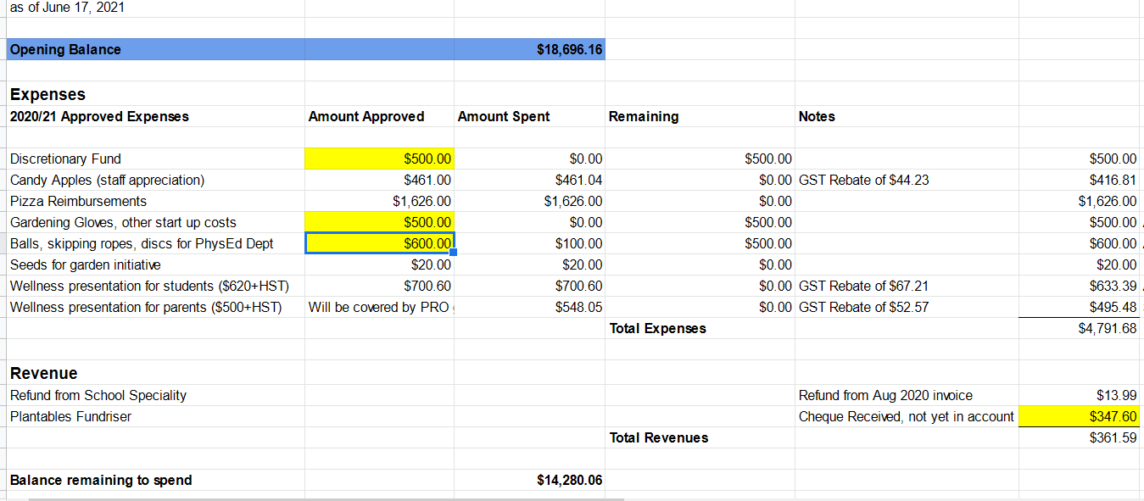

7: Ukuleles at VH

- Last year, it was a challenge to teach music with no singing
- This year, 2 groups sang at our Remembrance Day assembly and intermediate classes started to use the music room!
- From Mrs. Bender
- VH owns 60 ukuleles, which were purchased at the opening of the school. They have been well-used, and some are showing quite a bit of wear and tear, but for the most part they are still in good shape. Under normal circumstances (students from different classes using the same set of ukuleles), we have more than enough for a class set. Of course...the last two years haven't been normal! I asked students to purchase a ukulele, if possible, because with the current covid rules for sharing materials and disinfecting between use, it would be too hard on the instruments to sanitize multiple times a day. Students who are not able to purchase a ukulele (or preferred not to) have a school-owned ukulele assigned to them to use. I *hope* that in the future, we won't have to sanitize instruments between use. When these restrictions lift, we should have enough ukuleles for a full class to use them, without asking students to purchase one. It would be rare, in normal circumstances, that we would have multiple classes playing together and need more than one class set.
- So, at the moment, we are all set for ukuleles! Thank you so much for thinking of the music program! Having the support of parent council means a lot!

8: Fundraising – PRO Grant, Pizza Days, Pita Days, TruEarth – Greg James and Melanie Roberts

- PRO Grant Application process is now open ($750)
  - We apply for this grant every year and have used funds to run Family Math Nights and the Sara Westbrook guest speaker last year, etc.
  - support projects and initiatives which remove barriers that prevent parents from participating and engaging fully in their children’s learning and education.
  - Aimed at achieving diversity, equity and inclusion.
  - Melanie will form a subcommittee to consider ideas and proposal to submit our application this year.
  - Ministry Criteria for Project Funding
    - Address social inclusion and racism
    - Create a safe and welcoming environment
    - Demonstrate respect for parents as valued partners within the educational system
    - Enhancing communication with teachers
    - Informing parents about Ontario curriculum
  - Deadline: Friday, January 14, 2022
  - Brief ideas brainstorm generated the following:
    - Related to home reading or our guest speaker (leveraging existing initiatives at the school). Also could help fund an interactive art board at the school that coincides and supports the program criteria. Another idea included funding a free, diverse library in the community / on school property to align with initiatives being considered by the Vista Hills Community Association.
- Pizza Day – possible resumption in December / January
  - Twice the Deal Laurelwood interested
    - $8.75 per 10 slice pizza (Pep / Cheese)
    - $10 per 10 slice pizza for Gluten Free (Veggie)
    - Individual packaging by vendor is challenging and costly
    - $.12 per order for bag and plate (to reduce touches)? Could we source this cheaper?
    - 1 free pizza for every 25 ordered for events
- Pita Day – possible resumption in December / January
    - Brian (owner of Pita Pit) is open to similar program as previous years, including once per week frequency if desired.
      - $5.50 per order, all individually wrapped
      - Paper orders or set up online with SchoolDay
- Still researching other lunch purchase options but waiting for more information on policy / constraints from the Board due to Covid 19.

- TruEarth Fundraiser - Reminder
  - https://fundraising.tru.earth/VistaHills
  - Use this link when purchasing eco friendly
  - Laundry detergent and other items, and Vista
  - Hills will receive 20% of your order total

9: Fundraising Motions for consideration – All

- Focus on Nature - $1000
  - Jennifer Christopher Motioned; Bhaleka Persaud Seconded. Motion Passed.
- Guest Speaker – up to $1000 to start
  - Diana Clipsham Motioned; Raneed Al-Halimi Seconded. Motion Passed.
- Home Reading - $1000 for Primary / Kindie book replenishment.
  - Diana Clipsham Motioned; Anne Plouffe Seconded. Motion Passed.

10: Q & A

- Shawn Humes presented the new website for the Vista Hills Community Association
  - www.vistahillswaterloo.ca

Spending Summary:
- Hershey’s Kisses for Traffic Safety Blitz: $50
- Focus on Nature: $1000
- Guest Speaker: $1000
- Home Reading Primary/Kindie book replenishment: $1000

Next virtual meeting will be Thursday, December 16th at 6:30pm

