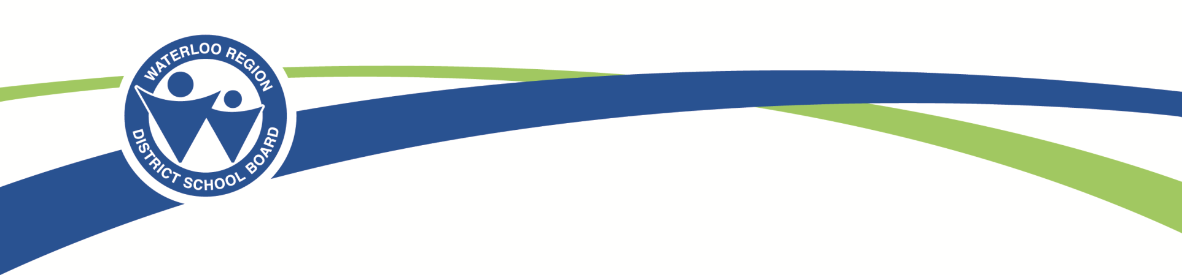

The Waterloo Region District School Board
is going online!

WRDSB Communication Survey for Parents/Guardians

In order to help us better understand our parent/guardian preferences for receiving information, an on-line survey has been created to gather input on ways to improve communication, streamline processes and reduce the use of paper within school communities. This initiative is in alignment with the continued work of engagement and communication within the Waterloo Region District School Board.

This survey can be accessed through a link called “Communication Survey for Parents” found on the Waterloo Region District School Board website at: http://wrdsb.on.ca or on the school’s website at: (insert school website address here).

The survey will open on May 15th and will close on June 5th.

All parents/guardians of Waterloo Region District School Board students are requested to complete this short survey at their earliest convenience. Responses to the surveys are anonymous and confidential.

Thank you for helping us understand your preferences for receiving information.

