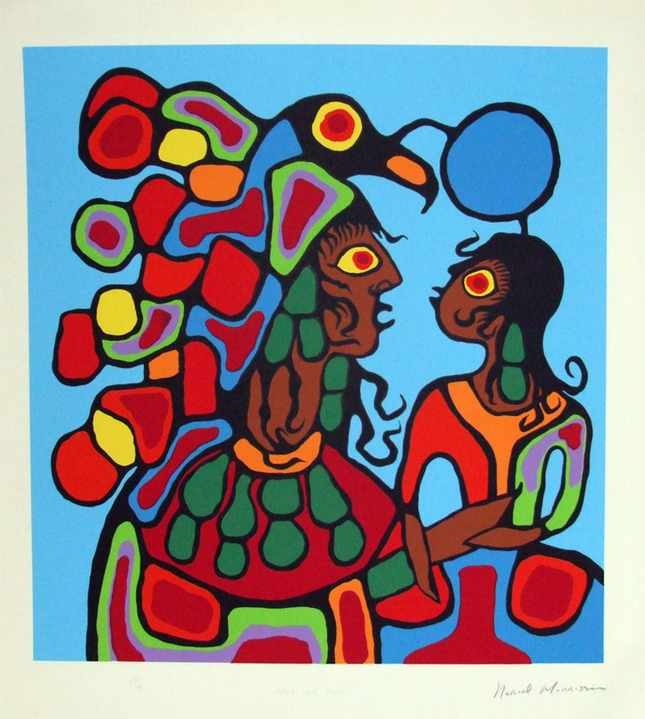
Native Art
Norval Morrisseau

Norval Morrisseau, also called Copper Thunderbird, is a Canadian Native artist who fuses Ojibwa spirituality with contemporary art methods. Born in 1969, on Sand Point Reserve near Thunderbay, Ontario, Morrisseau was raised by his grandfather who introduced him to Ojibwa shamanism and told him stories and legends passed down amongst the Ojibwa people. Morrisseau began illustrating these stories by drawing images on sandy beaches and letting the waves take the images away. He was told by the elders in his community that it was taboo to relate these sacred stories. However, Morrisseau believed he was born to paint and developed a style known as the Woodland School. Today this art style is called Anishnaabe painting, a reference to the artist’s heritage.
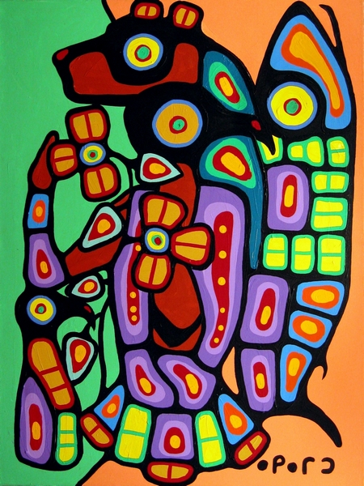
Morrisseau paints animals, plants, ancestors and spiritual creatures that reflect Ojibwa images taken from ancient pictographs, birch bark scrolls, and stories told by his grandfather. Characteristics of Morrisseau’s paintings include x-ray perspectives, vibrant colours, heaving black outlines, skeletal shapes and interconnecting lines that symbolize sacred power.

Morrisseau’s works appear in galleries across Canada and the U.S. He was the first Native Indian artist to have a solo exhibition of his work displayed at the National Gallery of Canada in its 126 year history. He died in 2007. His son Christian, has followed in his footsteps and has carried on the Woodland style in his own art and has become an accomplished artist in his own right.

Northwest Pacific Coast Art

Northwest Pacific Coast Art refers to the art created by First Nations along the northwest pacific coast – which includes areas such as B.C., Alaska and Washington. While many of these First Nations artists are unknown, their art has been preserved in the form of carvings, masks, totem poles, paintings, Chilkat blankets, canoes and household items. The subject matter of their art forms reflects animals, humans, nature, ancestral stories, and mythological creatures. Since much of the First Nations history is based on oral history, their art reflects much about their culture and beliefs.

The Haida – one of the First Nations – are well-known for their symmetrical flat designs that are made up of complex shapes that represent the Chief of the Undersea World – a supernatural being found in all Northwest Coast art. It is believed that the souls contained in this being are awaiting for rebirth above the sea. Totem poles are also closely associated with Haida art and are erected in front of homes and represent family crests, clans and chiefs. They also act as mortuary poles to commemorate a deceased person. Some bodies have been also placed inside these mortuary poles. This monumental sculptural design was sadly abandoned during the 1860s due to diseases and deculturation brought by Europeans and missionaries.

Characteristics of Northwest Pacific Coast art includes heavy black formlines which outline the main shape of the animal/person as well as U-forms, S-forms and ovoids – which resemble rounded rectangles. Ovoids are used to depict creatures’ eyes and joints. Other faces are often shown inside ovoids as they believed that the soul often leaked out through the body’s orifices and joints. Animals are also shown as having faces within their forms to represent death as well as rebirth. Although there are subtle differences in shapes and style between First Nations artists, they all share common forms, outlines, and a flat 2D style. Common colours include black, red, blue-greens, blues and yellows.
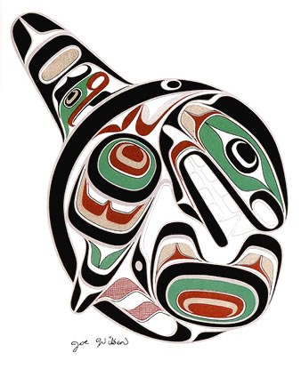
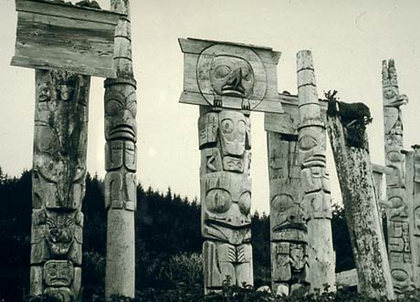
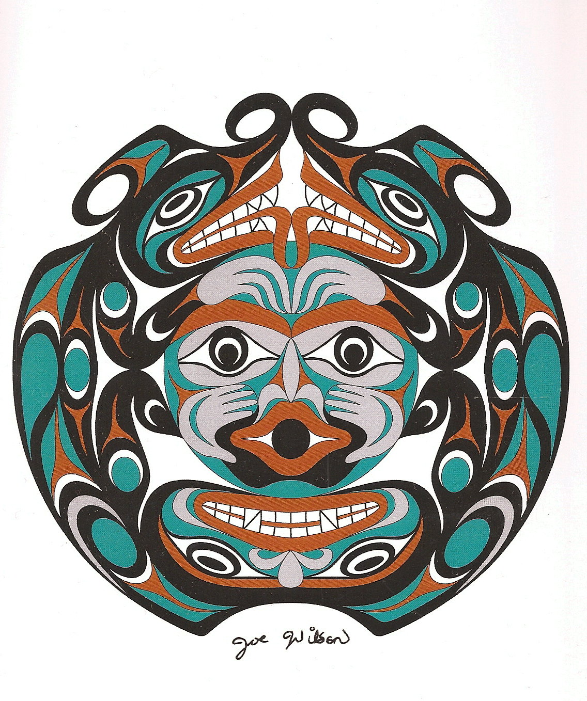

Sketchbook Assignment: Native Art Inspired Animal

Choose an animal that is important to Northwest Pacific Coast/ Woodland art and create a native inspired design that reflects these First Nations style of art. Complete in coloured pencil crayon and black felt-tip marker. Include the following in your design:

- Cut/print out two animals from the provided resource sheets or websites of your choosing and glue them into your sketchbook. Glue them down so that you are creating a new MORPHED ANIMAL design that is balanced and reflects an organic shape. E.g. Head of a bear morphed with the body of an eagle. You may also have a symmetrical design that has a mirror image of the same animal.

- Draw a ruler-width border around your page. Redraw a SIMPLIFIED OUTLINE of your morphed native animal. You may warp and contort the animal further so the outer edges reflect an organic shape such as an oval or circle.

- Tattoo the internal anatomy of the animal using shapes, interconnecting lines and anatomical features reflective of Northwest Coast and Woodland art as well as your own imagination. Use the provided resource sheets to help you design body parts such as wings, tails, claws, etc.

- Choose a vibrant colour scheme that uses a minimum of 3-4 colours. Complete using a flat, graphic colouring style or use a “halo” effect for shapes and background. The background must be coloured.

- Outline all shapes in black felt-tip marker.

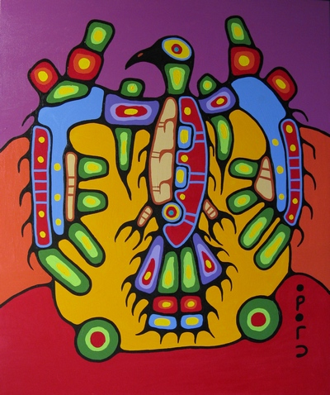
REMEMBER: In traditional Native art, animals are NOT realistically portrayed. Everything is simplified and stylized.

DUE DATE: _______________________________


