Storybook Illustration: Summative

Assignment: You are going to create a STORYBOOK ILLUSTRATION of an alliteration sentence that contains a character, action, and setting.

E.g. Hungry Hippos Hop Happily on a Hill with Hula Hoops Hugging their Hips

Process:

1. In your sketchbook, write 3-4 different ALLITERATION SENTENCES that you would like to illustrate. They must contain a CHARACTER, an ADJECTIVE (a word that describes the character), an ACTION, an ADVERB (word that describes the verb), an OBJECT and reference to a SETTING (time and place). They should contain a minimum of 7-8 words. Choose your favourite one to illustrate. (5 marks)

2. Design 4-5 rough thumbnails in pencil of the potential MAIN CHARACTER(s) that will appear in your illustration (4 thumbnails on one page). (5 marks)

3. Draw 4-5 different FACIAL EXPRESSIONS/POSES of your character in your sketchbook. (5 marks)

4. Draw 2-3 rough thumbnails of SETTINGS for your character. (3 marks)

5. Hand render or print out alliteration sentence in 2-3 interesting TYPEFACES that reflect the mood of your illustration and glue in sketchbook. (2 marks)

6. On newsprint that is the same size as your good copy (14” x 22” – ½ sheet of Bristol board), draw out your final ROUGH COPY for your storybook illustration. Hand in for teacher approval before receiving good copy paper. (20 marks)

7. Shade on the back of your rough copy in pencil and transfer onto GOOD COPY paper by tracing over design. Be sure to leave at least a one-inch border around your good copy.

8. Using a combination of PRISMACOLOUR MARKERS, WATERCOLOUR, and PENCIL CRAYON, render your illustration, being sure to show a wide range of values. OUTLINE design in BLACK FELT-TIP MARKER when finished.

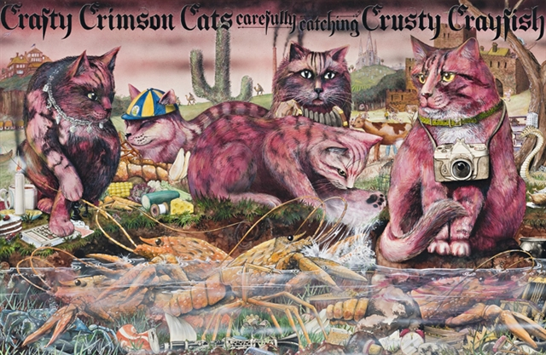
9. Sign and date your work in the bottom right-hand corner.

Evaluation: 30% of FINAL MARK

Preliminary sketches: 20 marks
Rough Copy: 20 marks
Good Copy: 60 marks

TOTAL: /100 marks

