Group Programs – Winter 2021
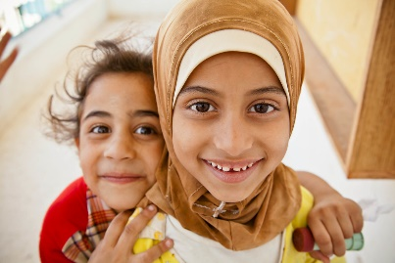
Newcomer Mental Health & Well-being Program
Aligning Mental Health Services for Refugees and Persons with Protected Status
Promise of Partnership

Group Programs – Winter 2021
Group programs are planned and facilitated based on community needs and interest and approached with a great degree of cultural humility. Promise of Partnership offers group programs for all ages to support Newcomers who are Government Assisted Refugees, Privately Sponsored Refugees and persons with protected status. This winter we will be offering:
Empowering Youth on Anti-Racism
Starting Thursday Jan 21st -Mar 11th 8 weeks, from 3:45-5:15pm, POP team is hosting an all gender Newcomer Youth group (high school aged). This group aims to create a safe and accepting environment where youth can explore issues of racism in our current social climate and our community. This group will be an opportunity for youth to discuss the impact of racism, recognize manifestations of racism, examine assumptions and beliefs about racism, and receive the support and encouragement to begin the healing process. The group will explore resilience strategies with a focus on Mental Health and Well-being. $10 Walmart card provided for each week attended.
We the Youth
This all-gender youth group for 9-12-year old will be held on Wednesday’s from Jan 20th- Mar 10th 4:30-5:30pm. Connect with other youth in our virtual group! Through games, art, sport, and EFT (what is that? - come find out!) we will explore a wide range of issues that impact well-being during the Pandemic and explore new ways to connect virtually! All group materials will be provided in a group kit and delivered to you!
Talk it Through
Do you find parenting in a new culture stressful? Does the pandemic cause challenges for you and your family? Do you find it frustrating trying to connect with your older child or teen? Then come Talk it Through with us and other parents just like you! Join us virtually on Tuesdays from 12-1:30pm starting Jan 19th -Mar 9th. $10 grocery card provided for each week attended.
All group programs are free of charge.

TO REGISTER OR TO LEARN MORE
Contact: promise@carizon.ca or 519-743-6333 Ext. 2383
