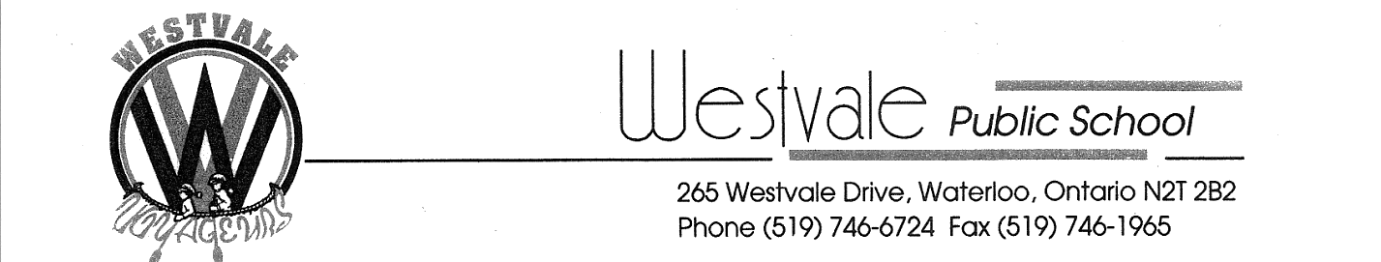

September 15 2015

Dear parents/guardians,

Nutrition for Learning has been a registered charitable organization since 1997. We support community based nutrition programs committed to improving the learning capacity, health and well-being of children and youth in Waterloo Region. We are a program whose mission is to enhance the ability to learn by ensuring that each student attends school well-nourished. Westvale Public School plays a great part in this program by allowing the breakfast club to serve breakfast every weekday morning in the school from 8:15-8:45 am. The program will be starting this year on Monday September 28, 2015.

This program is free for all students who would like to receive a healthy breakfast or snack and hang out with their friends before classes begin. We offer at least three food groups from Canada’s Food Guide, with an emphasis and accommodate for all food allergies and religious needs.

As outlined in the program guidelines, parents must be given the opportunity to donate funds. At this time we are asking for parental contributions to help support our program. We receive grants from the Ministry of Children and Youth Services for a portion of costs and must raise the additional funds.

Cheques are made payable to Nutrition for Learning. Please note that the nutrition program is universal for all students and is available whether you contribute financially or not.

This program runs on student participation and volunteer hours alone, so the more students who come out to have breakfast, the more funding the program receives, allowing its continuation. As the program is operated by volunteers, you may also sign up to assist in the morning for set up and serving food. It is a once or twice weekly commitment from 8:00 to 9:00 am.

(please complete the form on the back of this page if you can help us help kids).

Thank you for your continued support of our program. If you have any questions, please do not hesitate to call the school at (519) 746-6724 or contact the program coordinator Jaclyn Roberts at 519 747-0532.

For more information you can also check out the Nutrition for learning website: www.nutritionforlearning.ca

Best Regards,

Bruce Alexander
Principal

This form is to be filled out and returned to Westvale Public School

Would you be willing to contribute toward the cost of the program?
(The cost per child per school year is $1.30 per day, over the course of a school year is $48.10)

$5 $10 $20 $48.10 per child Other Not at this time

Would you be willing to contribute your time once or twice a week?

Yes No

If you are able to volunteer, please provide:

Name: ______________________________

Phone number: _________________________

Email: ________________________________

Available mornings to volunteer: ______________________________________
(Monday, Tuesday, Wednesday, Thursday, Friday)

